**DevOps Certification Training**

**Certification Project – Finance Me Banking and Finance Domain**

FinanceMe is a Global leading Banking and Financial services provider based out of Germany. The company offers products and services like Banking, Funds Management, Loans, Debit Cards and Credits Cards, Investment Banking etc. Initially the company was using a Monolithic application architecture, As the company grown, It started facing difficulties in managing the application infrastructure and application deployments and Scaling of application when the traffic load increases.

FinanceMe has decided to opt for microservice architecture for its applications and decided to go DevOps by implementing necessary automations using CICD FinanceMe has decided to use AWS as primary cloud services provider to create servers, databases and application deployments.

The company’s goal is to deliver the product updates frequently to production automatically with High quality & Reliability. They also want to accelerate software delivery speed, quality and reducing feedback time between developers and testers.

Currently, they are facing following problems, because of various technologies involved in the project.

Building Complex Monolithic Application is difficult.

Manual efforts to test various components/modules of the project

Incremental builds are difficult to manage, test and deploy.

It was not possible to scale up individual modules independently.

Creation of infrastructure and configure it manually is very time consuming

Continuous manual monitoring the application is quite challenging.

In order to implement a POC, you are requested to develop a mavenized microservice using spring boot and in memory h2 database.

1. a microservice which exposes below mentioned endpoints as APIs and uses pre configured AWS RDS – mysql database to store the data.

a. /createAccount (HTTP Method : POST) (Request Body : JSON)

b. /updateAccount/{account no.} (HTTP Method : PUT ) (Request Body : JSON)

c. /viewPolicy/{account no.} (HTTP Method : GET ) ( No Request Body )

d. /deletePolicy/{account no.} (HTTP Method : DELETE) ( No Request Body)

2. Write necessary Junit testcase.

3. Generate HTML report using TestNG.

4. Push your code into your GitHub Repository.

Note : Preload some data into the database.

Later, you need to implement Continuous Integration & Continuous Deployment using following tools:

✓ Git - For version control for tracking changes in the code files ✓

Maven – For Continuous Build ✓

Jenkins - For continuous integration and continuous deployment ✓

Docker - For deploying containerized applications ✓

Ansible - Configuration management tools ✓

Selenium - For automating tests on the deployed web application ✓

Terraform - For creation of infrastructure. ✓

Prometheus and Grafana – For Automated Monitoring and Report Visualization

This project will be about how to test the services and deploy code to dev/stage/prod etc, just on a click of button.

**Business challenge/requirement**

As soon as the developer pushes the updated code on the GIT master branch, the code should be checked out, compiled, tested, packaged and containerized. A new test-server should be provisioned using terraform and should be automatically configured using Ansible with all the required software’s and as soon as the server is available, the application must be deployed to the test-server automatically.

The deployment should then be tested using a test automation tool, and if the build is Successful, Prod server must be configured with all the software it should be pushed to the prod server. All this should happen automatically and should be triggered from a push to the GitHub master branch.

Continuous monitoring server must be configured to monitor the test as well as prod server using Prometheus and Grafana should be configured to display a dashboard with following metrics.

1. CPU utilization

2. Disk Space Utilization

3. Total Available Memory

Link for the Solution of FinanceMe project code is attached below. Use it to validate your solution.

\

Note : To have a detailed information about running the application and exposed APIs, Input/Output format, Refer to the README.md in the GitHub repository.

**Step1:- first I will launch the EC2 instance after launch install the terraform on this created ec2 instance.**

1. **Login my Aws account for launch ec2 instance.**

[**url:-**](url:-)[**https://signin.aws.amazon.com/**](https://signin.aws.amazon.com/)

**after open this URL click on Sign in to the console icon on the top right side.**

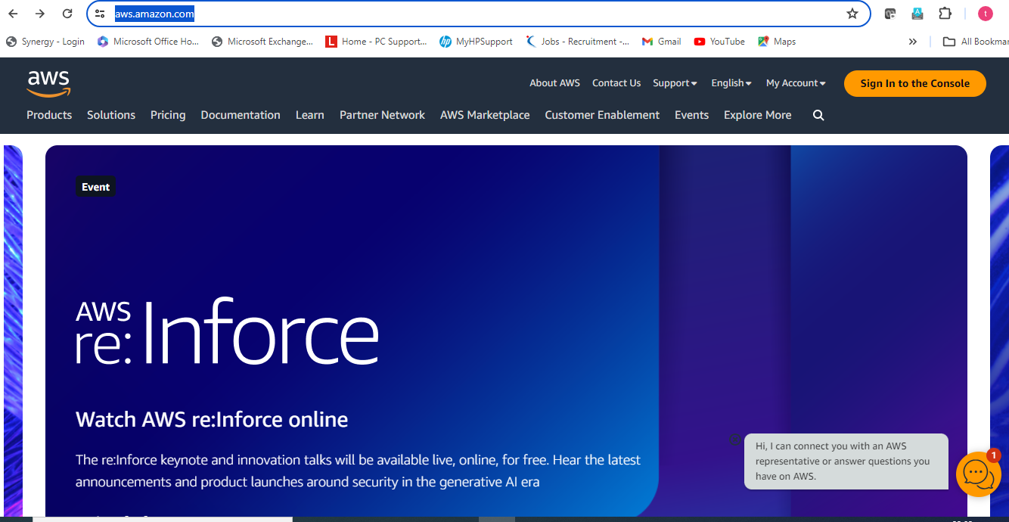

**After click on sign in to the console icon, login with aws credentials(user email-next)**

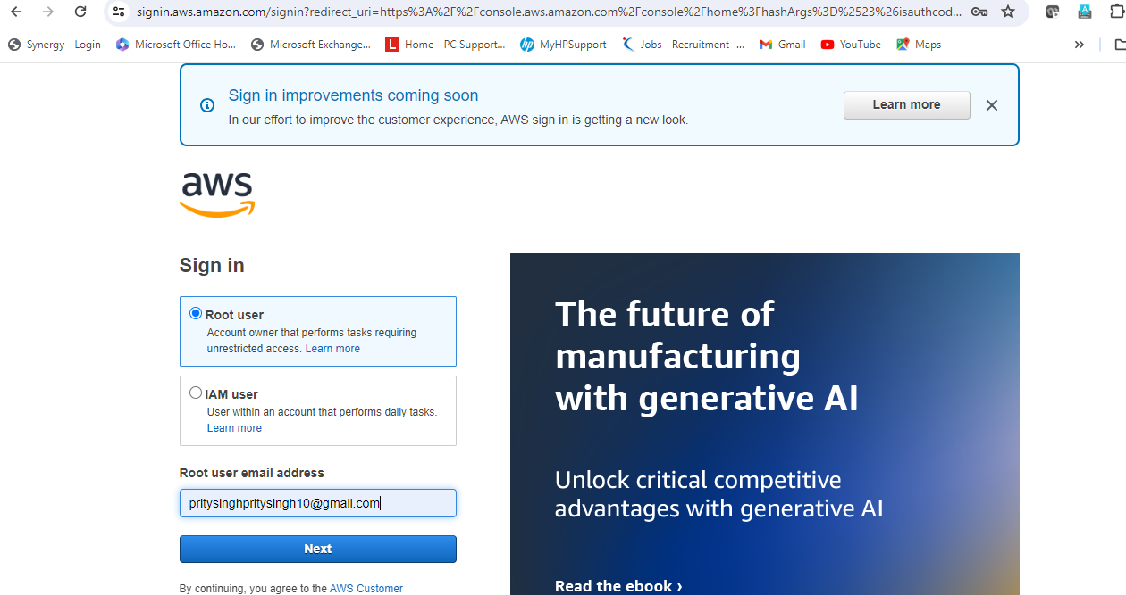

**After click on Next button on the bottom after put the Aws login password and then click on sign in button.**

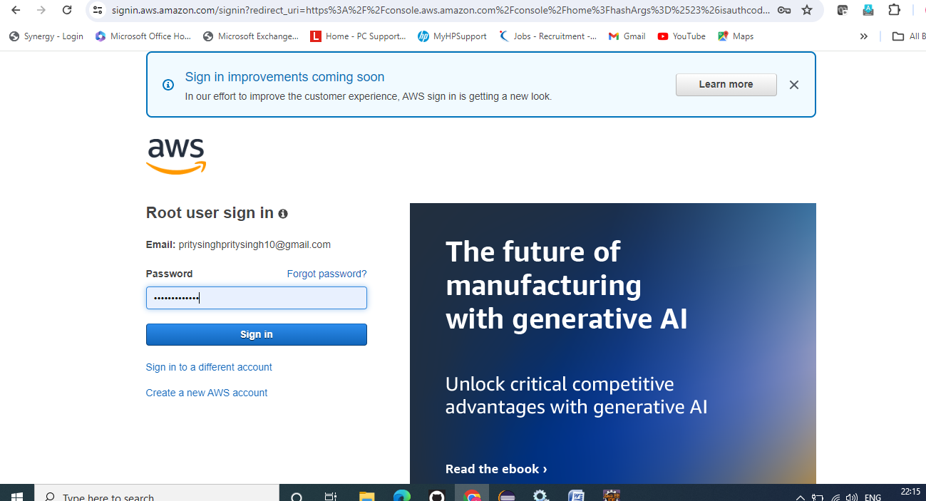

**After click on sign in button the below page will open**

**First, click on EC2 for create ec2 instance (if not showing EC2 go to search icon and then search EC2 and then click on Ec2 )**

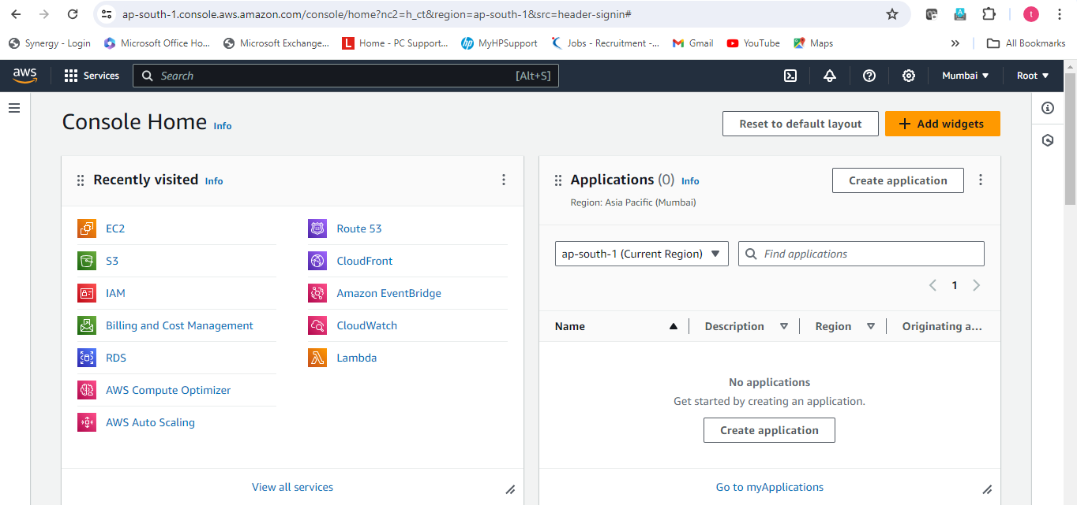

**After click on EC2, EC2 dashboard will open and then click on instances for launch the new instance.**

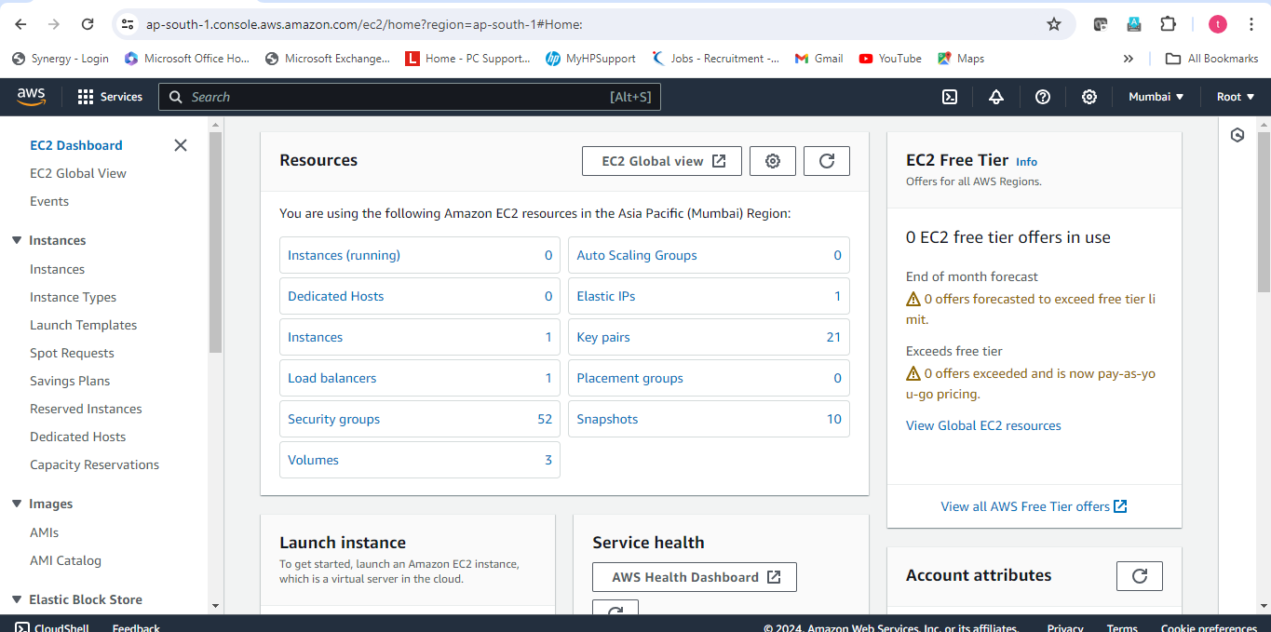

**After click on instances, the below page will be open and then click on Launch instance on the top right side yellow icon.**

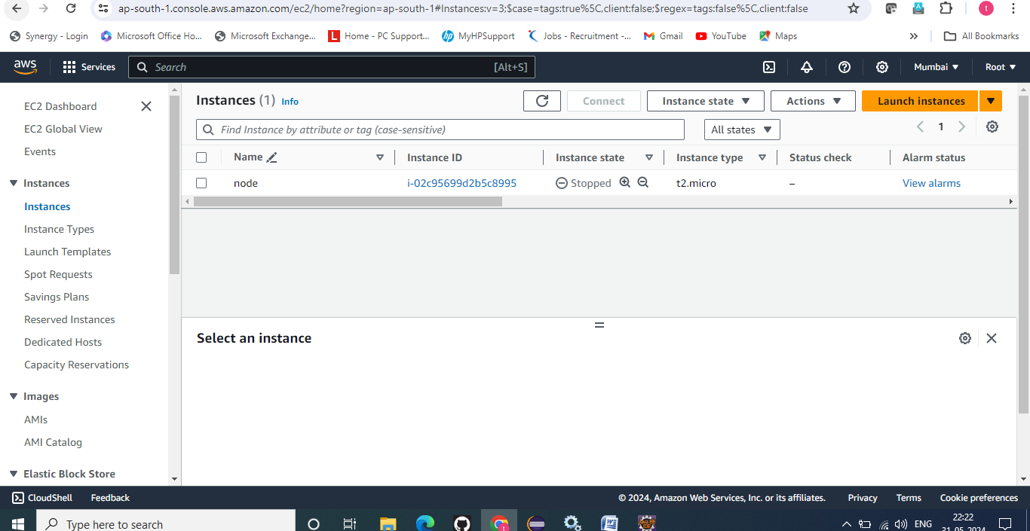

**After click on launch instance write the name and tags of the instance.**

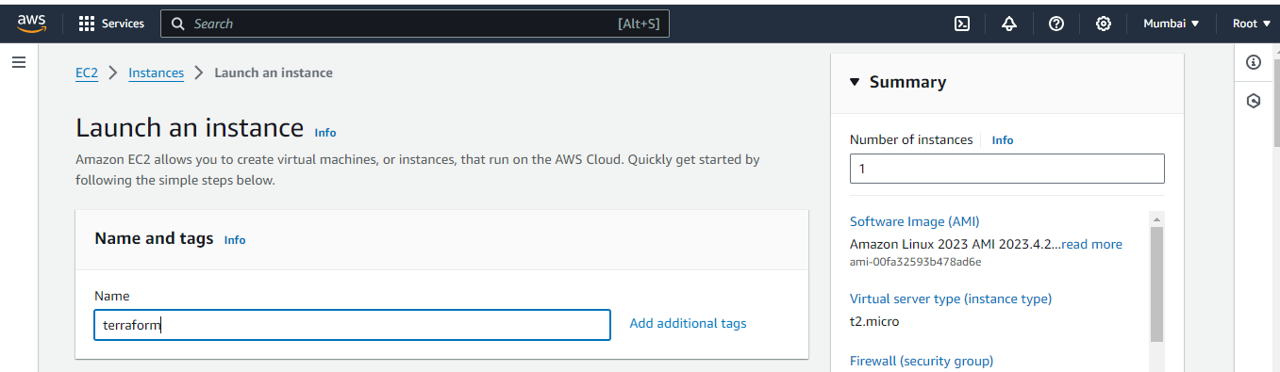

**after dropdown page select the Amazon machine image ( I am selecting ubuntu image)**

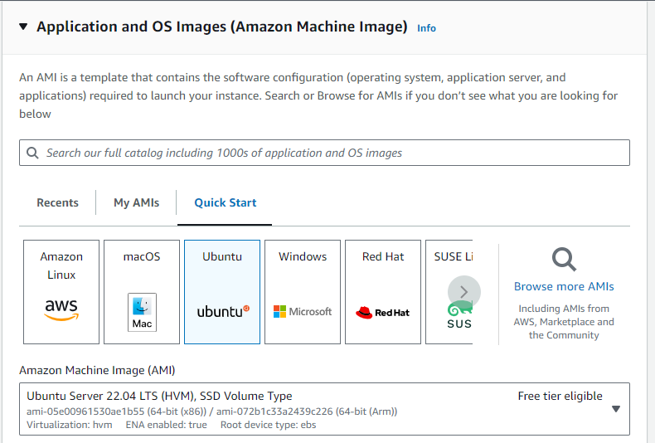

**After select amazon machine image again dropdown page and then select instance type and key pair(login)**

**Instance type:- t2.micro (preferred for free tier account)**

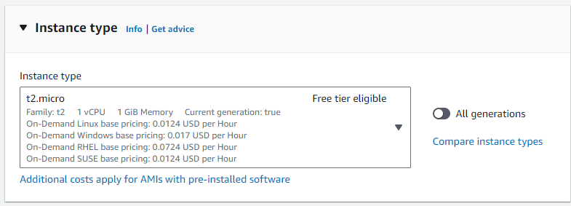

**Key pair :- (click on create new pair )**

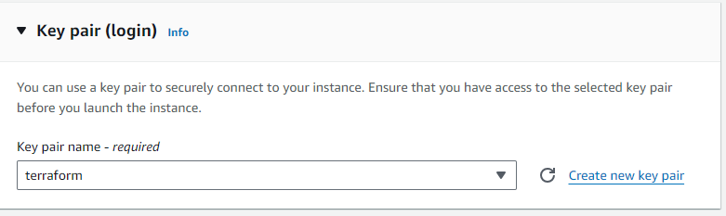

**After click on create new key pair write the name of key pair name and then click on create key pair.**

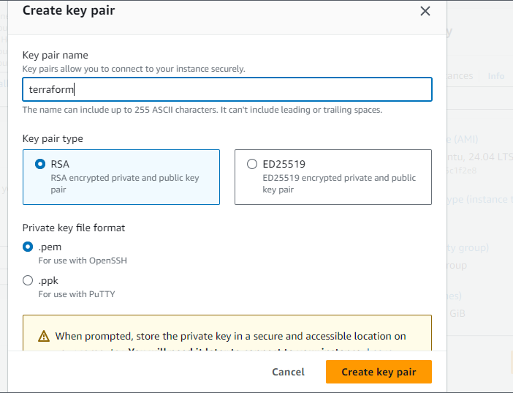

**Go to the network setting and then click on create security group**

**Tick-out on allow ssh connection**

**Tick-out on allow https traffic for internet**

**Tick-out on allow http traffic for internet.**

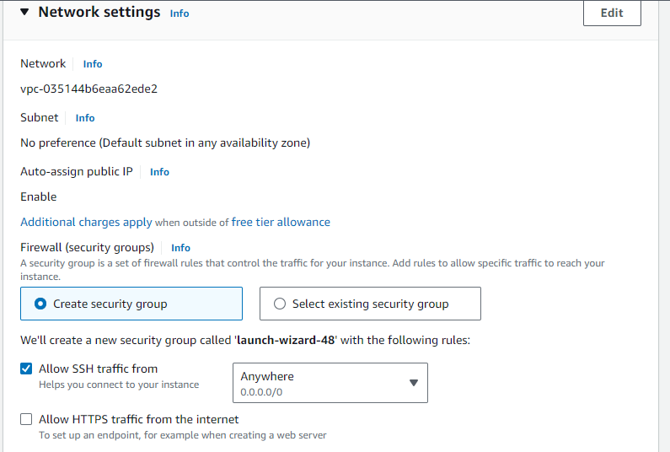

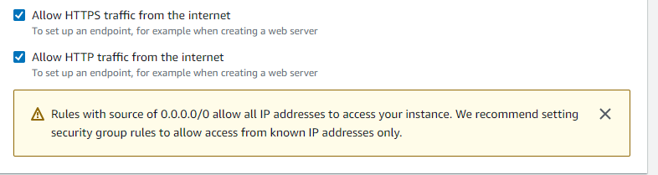

**After go to the configure storage and keep all the default no need to change and then click on Launch instance.**

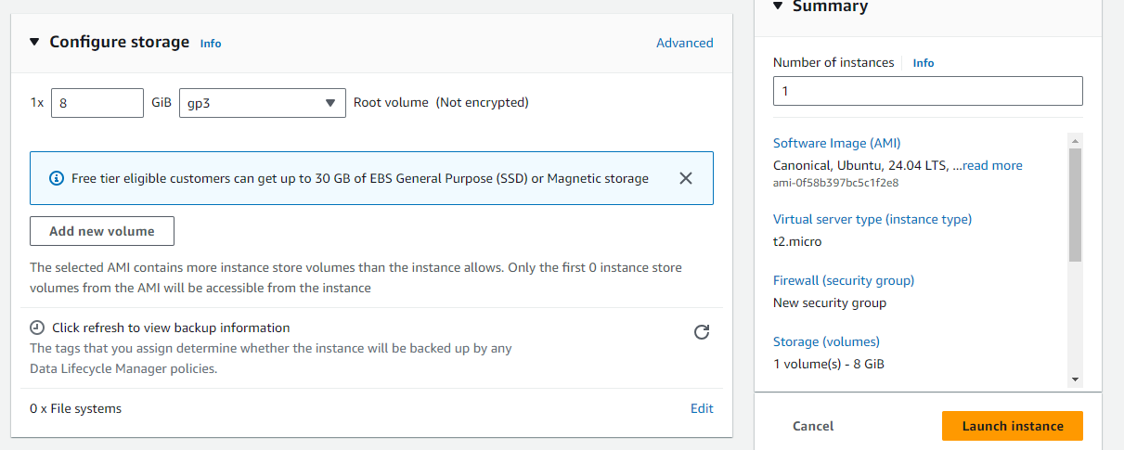

**After click on launch instance instance is launching**

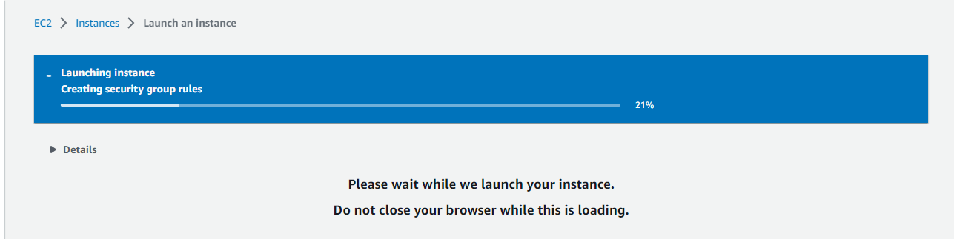

**After launch this instance has been successfully install. And then click on instance icon and check the status of the instance.**

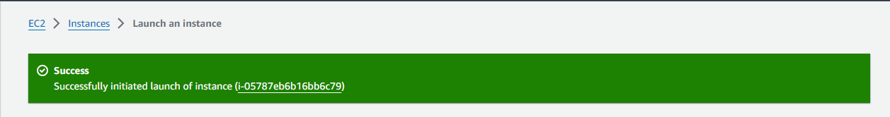

**I will wait 2min for launch the instance with all configuration.**

**If show the status 2/2 pass mean’s instance has been successfully launch.**

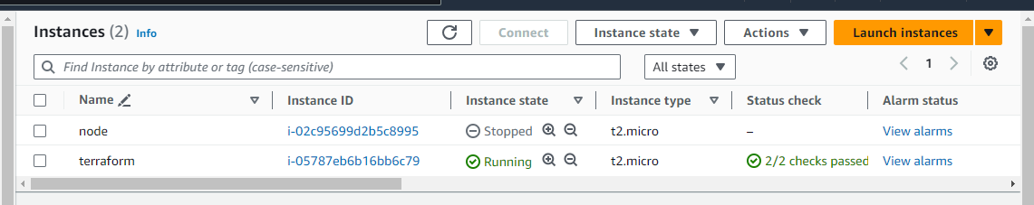

**After launch click on instance id**



**and dropdown and go to the security icon and then click on this.**

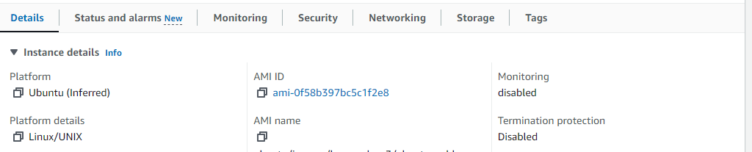

**Click on security groups.**

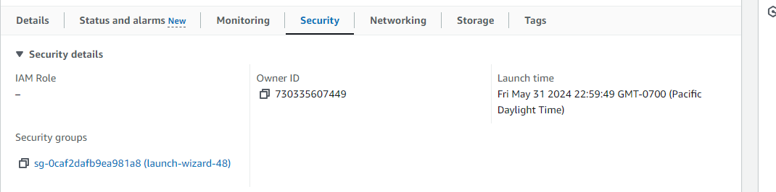

**And then drop down page and go to the inbound rules and click on Edit inbound rules.**

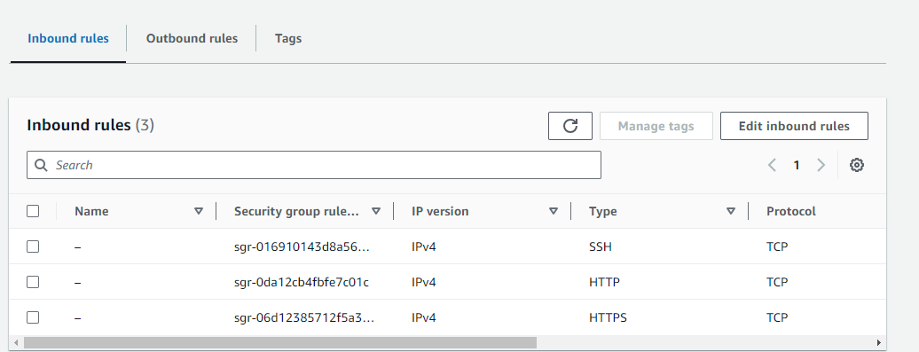

**And then click on Add rule icon and select type:- all traffic and source any traffic. (this is not recommended for allow all traffic ,but right now I will allow because further that will need to allow any traffic)**

**Click on save rules.**

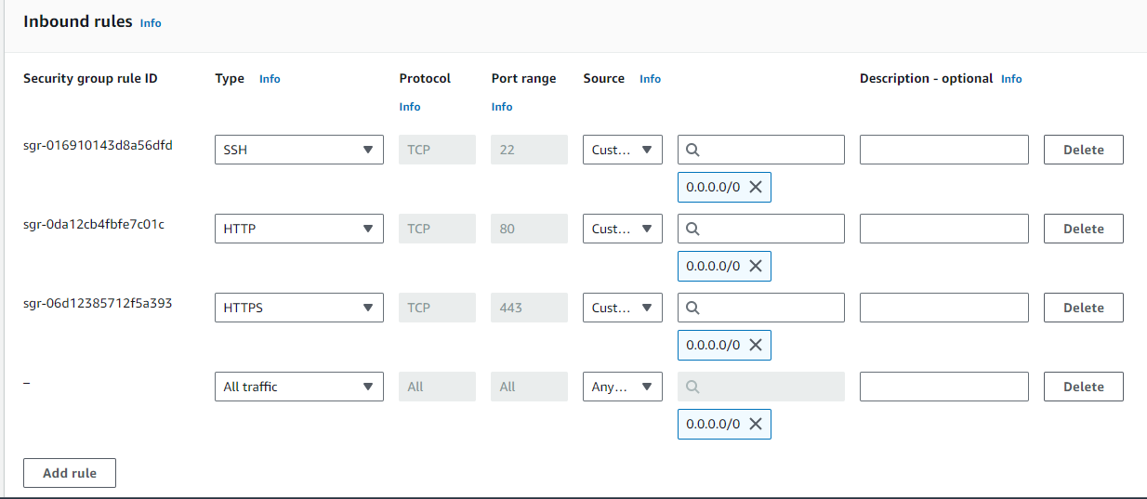

**After click on EC2**

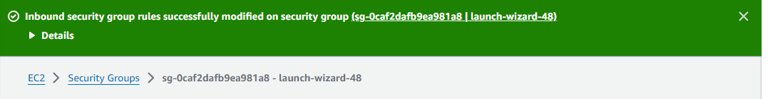

**And then click on running instance.**

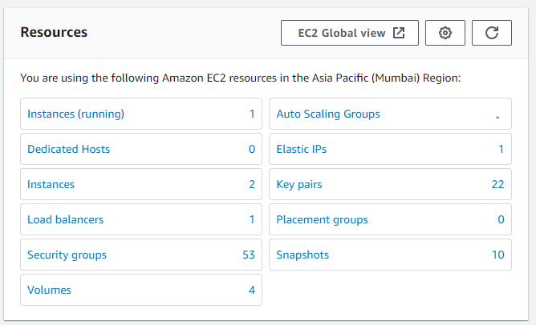

**And then click on instance id for connect the ec2 instance.**

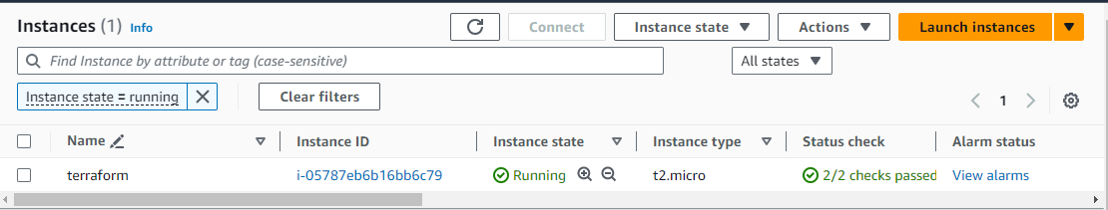

**And then click on connect icon for connect EC2 instance.**

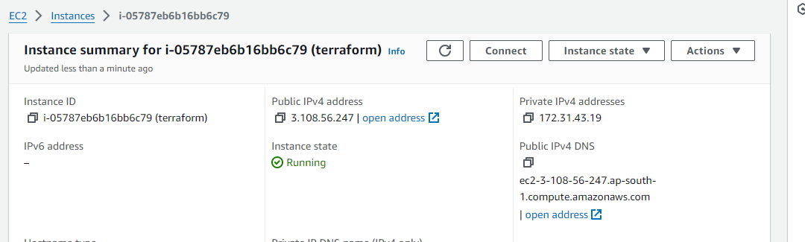

**And then click on connect on the bottom.**

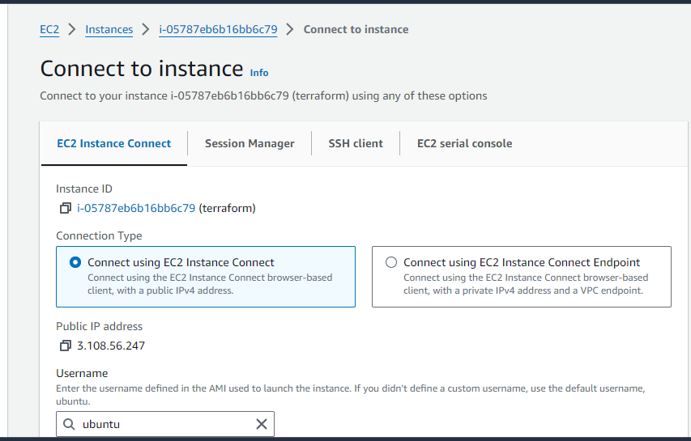

**After click on connect one new tab will open where instance is running.**

**After run login with root user.**

**Command:- sudo su**

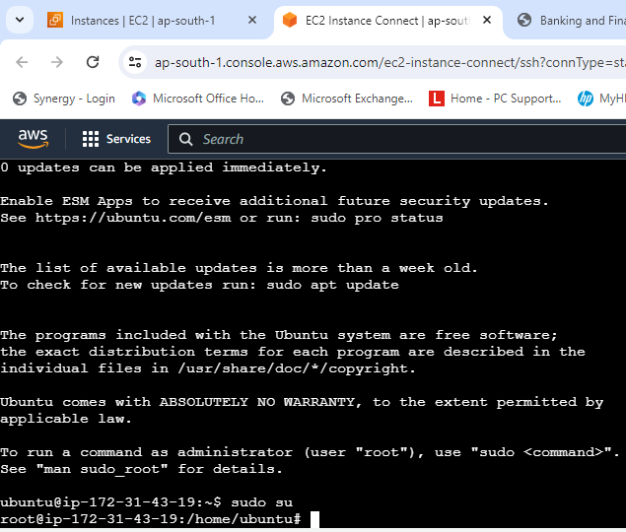

**After login with root user install the terraform.**

**Go to the internet and write the below** [**url:-**](url:-)

[**https://developer.hashicorp.com/terraform/tutorials/aws-get-started/install-cli**](https://developer.hashicorp.com/terraform/tutorials/aws-get-started/install-cli)

**after search url on internet open the below page after click on linux for install terraform on linux os.**

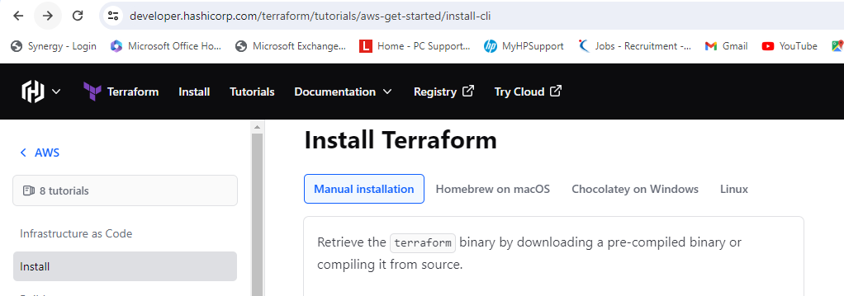

**And then select the linux distributiuon**

**I am selecting ubuntu because I have launched ubuntu instance.**

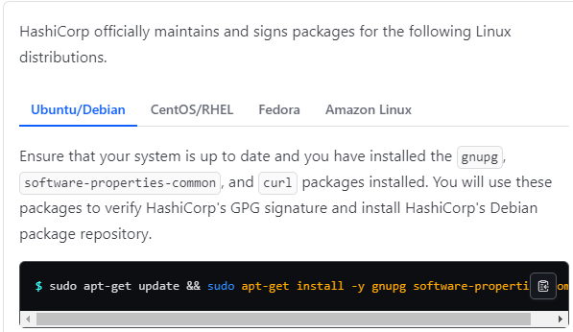

**And copy the below command from this one by one and paste on ec2 instance command line interface and then hit enter.**

**Command:-** **sudo apt-get update && sudo apt-get install -y gnupg software-properties-common**

**Command:-** **wget -O- https://apt.releases.hashicorp.com/gpg | \**

**gpg --dearmor | \**

**sudo tee /usr/share/keyrings/hashicorp-archive-keyring.gpg > /dev/null**

**command:-** **gpg --no-default-keyring \**

**--keyring /usr/share/keyrings/hashicorp-archive-keyring.gpg \**

**--fingerprint**

**Command:-** **echo "deb [signed-by=/usr/share/keyrings/hashicorp-archive-keyring.gpg] \**

**https://apt.releases.hashicorp.com $(lsb_release -cs) main" | \**

**sudo tee /etc/apt/sources.list.d/hashicorp.list**

**command:-** **sudo apt update (update instance for whatever chages by above command all will updated)**

**command:-** **sudo apt-get install terraform (install terraform)**

**after this comand check terraform has been installed or not.**

**Command:- terraform –version**

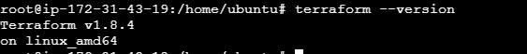

**So, finally terraform version v1.8.4 has been installed.**

**After terraform installatiuon create the terraform file( .tf extension) for create the new instance for install the more package such as jenkins, git, ansible,docker and maven.**

**Command:- vi terraform.tf (create the terraform file extension must be .tf)**



**Command;- press I button on keyboard for edit and write in file.**

**Go to the internet browser and write the below url.**

[**https://registry.terraform.io/**](https://registry.terraform.io/)

**after open the below page click on browse providers.**

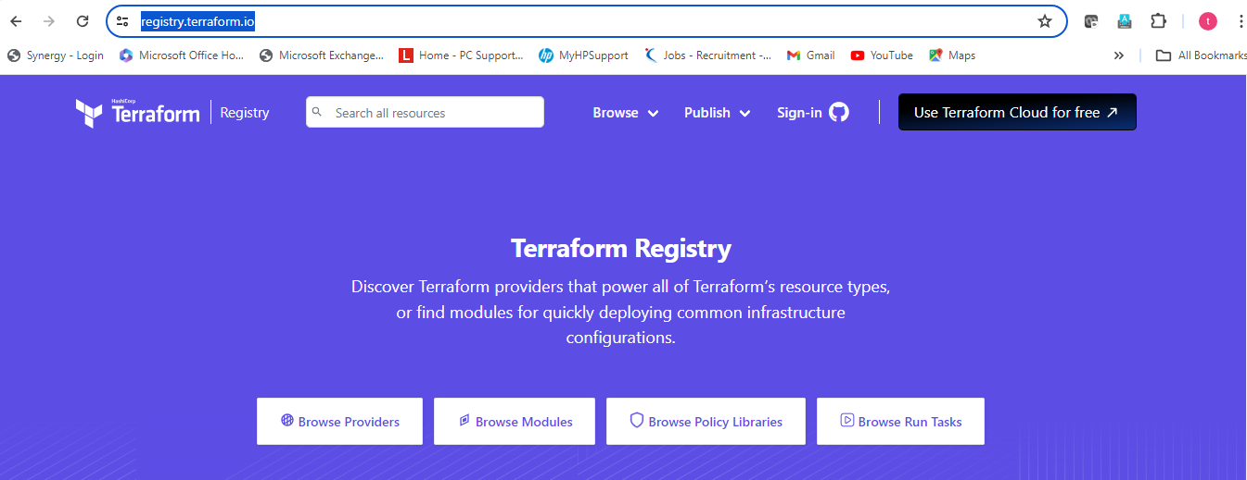

**Click on providers--aws.(because I am using aws cloud provider for launch the instance)**

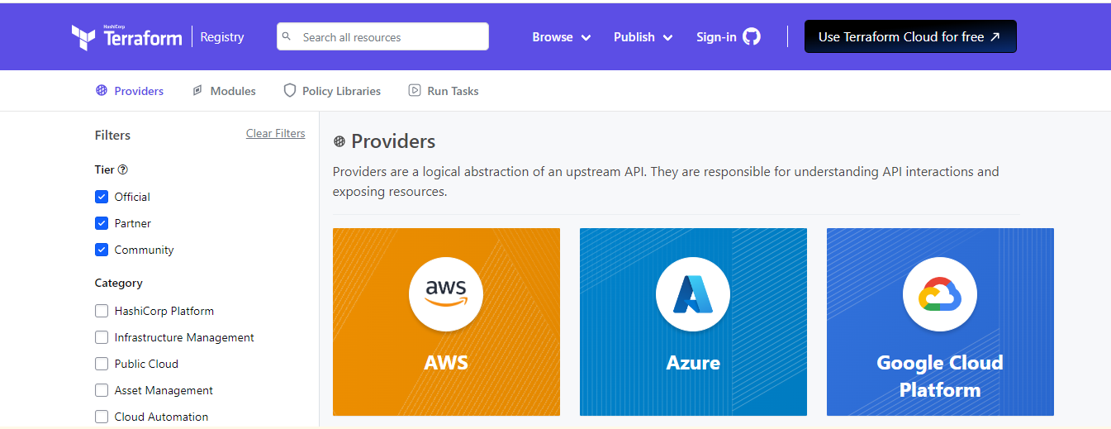

**Click on Documentation.**

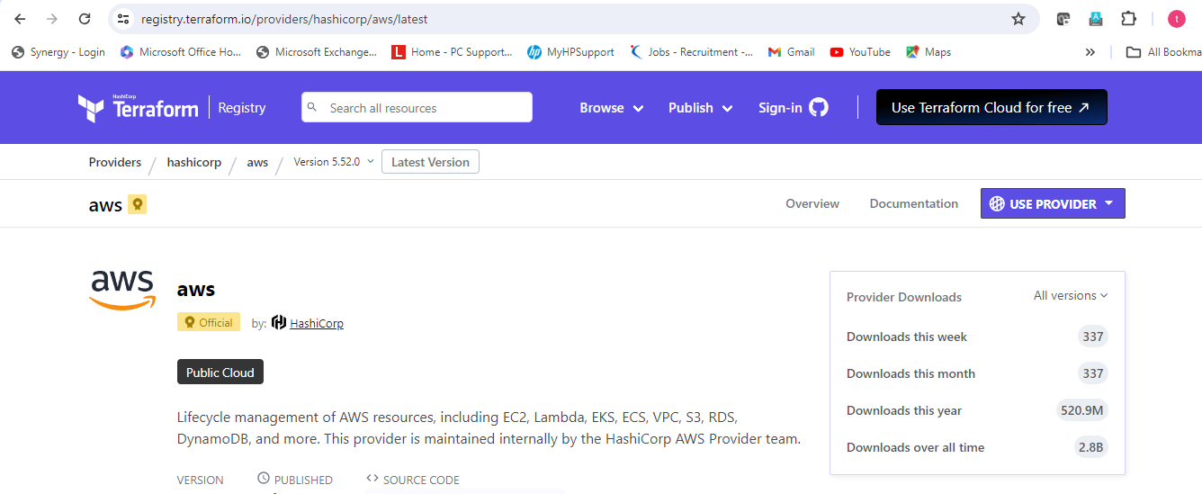

**After click on documentation drop down and copy the below command and then paste inside the terraform.tf file.**

**That command make the connection between aws and then terraform.**

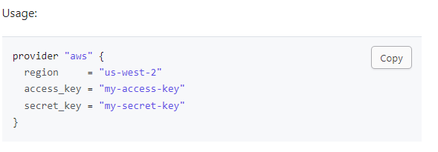

**Press i (inside file for edit.)**

**Change the region if you want**

**Region:- us-east-1**

**Put the access key and secret key here from own aws account.**

1. **First go to the aws account click on Root icon on right top. And click on security credentials tab.**

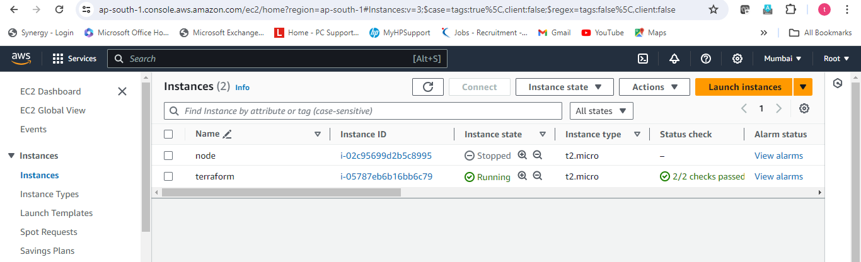

**Drop-down page ang go to the access key and then click on create access key icon**

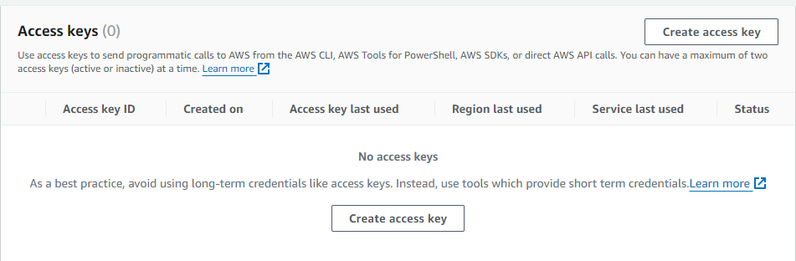

**Tickout the continou the create access key and then click on create access key.**

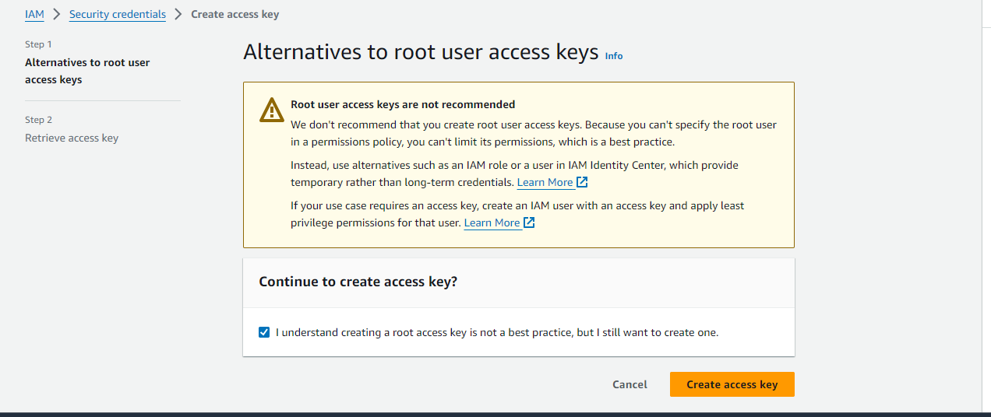

**Copy the access key and secret key and paste on notepad.**

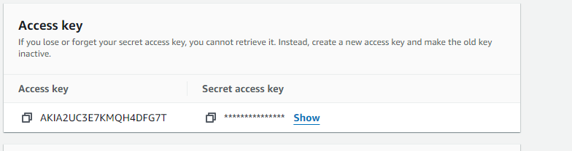

**And then click on done icon**

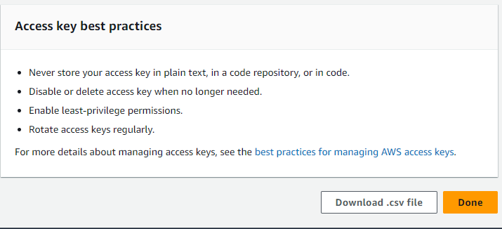

**And then continoue.**

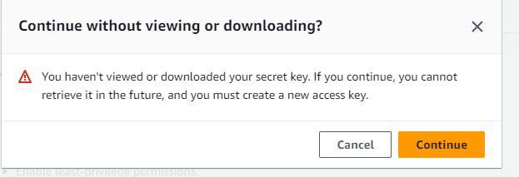

**After continoue go to the terraform.tf file and write the secret key and access key which has been past in notepad.**

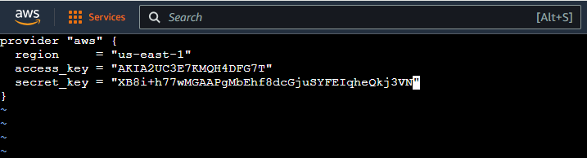

**After write the code.**

**Command:-ESC**

**command:-shift+:**

**Command:-wq (changes save)**

**Command:- enter**

**Run the terraform.tf file**

**Command:- terraform init (initialize and install and download the package, dependency of aws from terraform registry or hashicorp)**

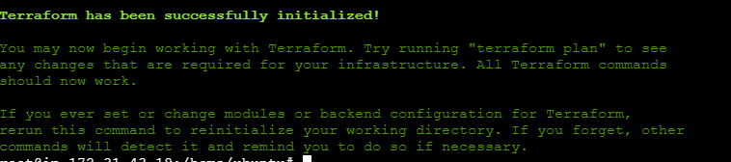

**Command:- terraform validate (validate the syntax of the code)**



**Command:- terraform plan (plan terraform how the run code step by step)**



**Command:- terraform apply (finally create as a written code)**

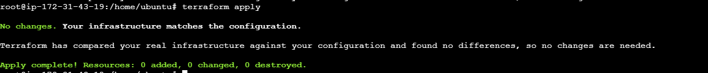

**Finally, all command run successfully and aws has been connected with terraform.**

**Again, go to the hashicorp registry and**

**Write the aws_instance left side on search icon and drop down and click on aws_instance**

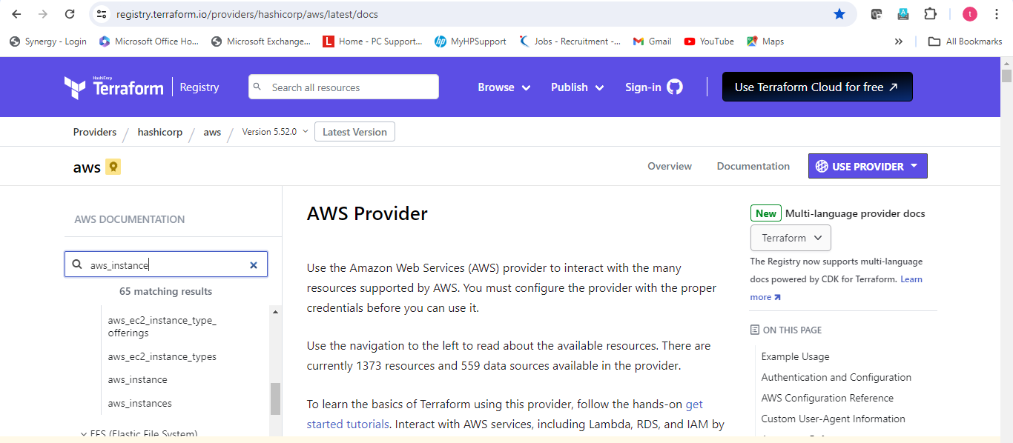

**After click on aws instance open the below page and copy the resources and then paste inside terraform.tf file.**

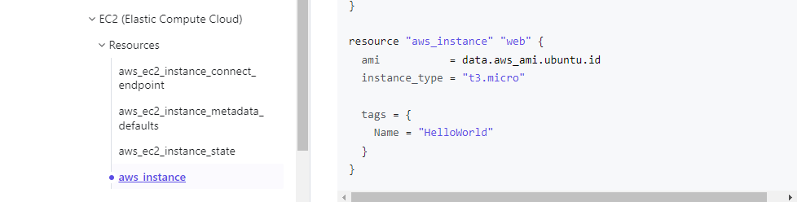

**Change the name of the resources if want.**

**Put the own ec2 instance ami.**

**Go to the aws ec2 instance**

**Click on launch instance and then select instance ami and then copy ami from there and paste here.**

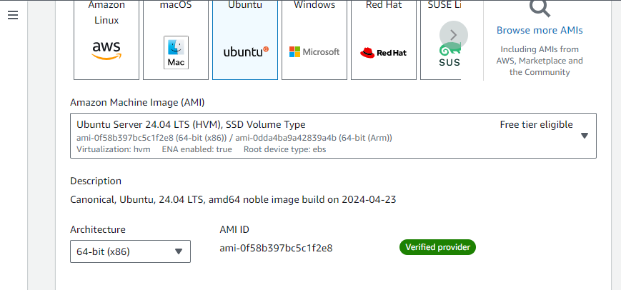

**Resource name:- my-terraform-instance**

**Ami image:- ami-04f58b397bc5c1f2e8**

**Type:- t2.micro**

**Tags:- terrafom instance**

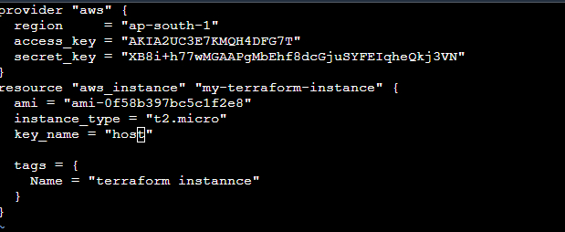

**Command:-ESC**

**command:-shift+:**

**Command:-wq (changes save)**

**Command:- enter**

**Run the terraform.tf file**

**Command:- terraform init (initialize and install and download the package, dependency of aws from terraform registry or hashicorp)**

**Command:- terraform validate (validate the syntax of the code)**

**Command:- terraform plan (plan terraform how the run code step by step)**

**Command:- terraform apply (finally create as a written code)**

**After run the above command go to the aws instances page and make insured select the region must be ap-south-1 and then check ec2 instance has been created or not.**

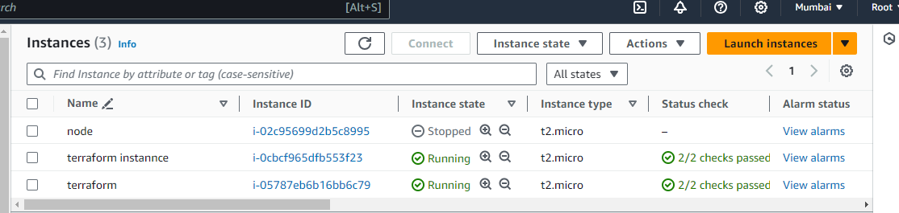

**So, again go to the ec2 command line interface and then install ansible.**

**Go to the below** [**url:-**](url:-)

[**https://docs.ansible.com/ansible/latest/installation_guide/installation_distros.html#installing-ansible-on-ubuntu**](https://docs.ansible.com/ansible/latest/installation_guide/installation_distros.html#installing-ansible-on-ubuntu)

**and then copy the code frome there and paste under command line.**

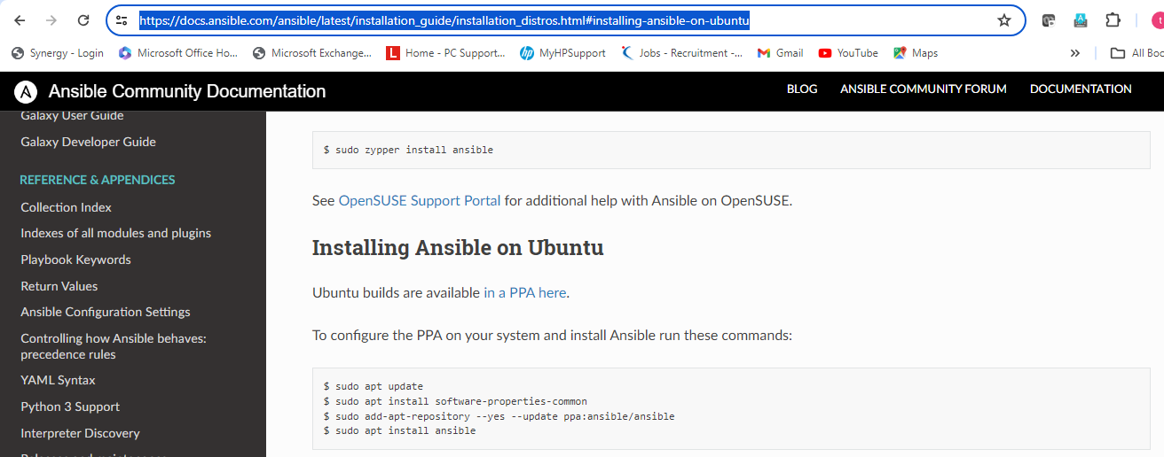

**Command:-**  **sudo apt update -y (first update instance)**

**sudo apt install software-properties-common**

**sudo add-apt-repository --yes --update ppa:ansible/ansible (add ansible repositry inside ec2 instance properties)**

**sudo apt install ansible -y (install ansible)**

**ansible –version (check ansible has been install or not)**

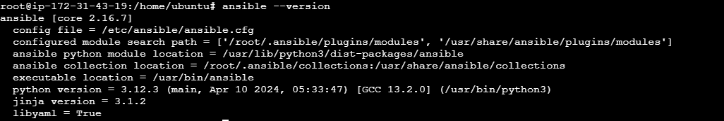

**So, finally install ansible .**

**Now go to the ansible hosts file and then add group and ip of the target node which want to connect with ansible.**

**Command:- vi /etc/ansible/hosts**

**Command:- press I (for edit)**

**Go to down of page**

**Write**

**[demo] (group name)**

**Public ip (ec2 instance which created by terraform)**

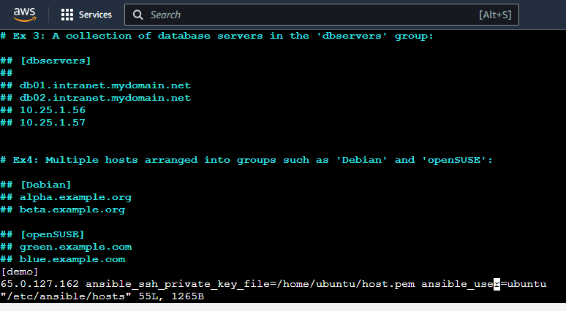

**Make sure your host.pem file is available on /home/ubuntu directory.**

**If not availbale so plaese copy from github or any another method.**

**I will copy the host.pem file from own gihub.**

**First I will push the host.pem file from downloads to github account**

**Command git push**

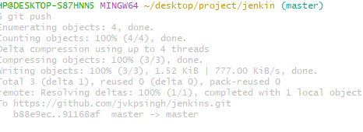

**After push host.pem file available on my github.**

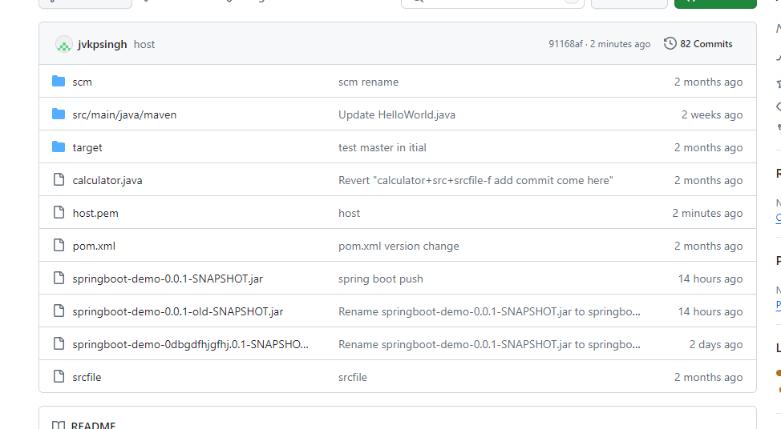

**After push clone the pushes file on own ec2 ansible master machine under /home/ubuntu location**

[**url:-**](url:-) **git clone** [**https://github.com/jvkpsingh/jenkins.git**](https://github.com/jvkpsingh/jenkins.git)

**host.pem has been copy from github to my ec2 instance.**



**After add the ip and create group inside ansible hosts file.**

**Check the connectivity with host machine:-**

**Before this command must me permission change of this host.pem file.**

**Command:- chmod 700 host.pem( without mod change that will not connect the come below error)**

**Check my ansible is connected with target machine or not.**

**Command:- ansible –m ping all**

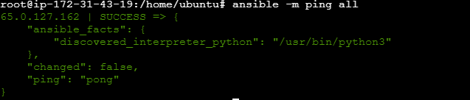

**The target node has been successfully connect with ansible server.**

**After write ansible playbook for install jenkins docker maven git on target host machine.**

**Commad:- vi ansible.yml (name will be custom not fixed but extension must be yml)**

**---**

**- name: install package**

**hosts: all**

**become: yes**

**tasks:**

**- name: install git**

**apt:**

**name: git**

**state: present**

**- name: install git**

**apt:**

**name: maven**

**update_cache: yes**

**state: present**

**- name: install docker**

**apt:**

**name: docker.io**

**update_cache: yes**

**state: present**

**- name: start docker service**

**Service**

**name: docker**

**state: started**

**- name: install java**

**apt:**

**name: openjdk-11-jdk**

**state: present**

**- name: Add Jenkins apt key**

**ansible.builtin.get_url:**

**url: https://pkg.jenkins.io/debian-stable/jenkins.io-2023.key**

**dest: /usr/share/keyrings/jenkins-keyrings.asc**

**- name: Add Jenkins repository**

**ansible.builtin.apt_repository:**

**repo: ‘deb [signed-by=/usr/share/keyrings/jenkins-keyrings.asc] https://pkg.jenkins.io/debian-stable binary/’**

**state: present**

**- name: update**

**apt:**

**name: "*"**

**state: latest**

**- name: install jenkins**

**apt:**

**state: latest**

**- name: install jenkins**

**apt:**

**name: jenkins**

**update_cache: yes**

**state: present**

**- name: start jenkins**

**service:**

**name: jenkins**

**state: started**

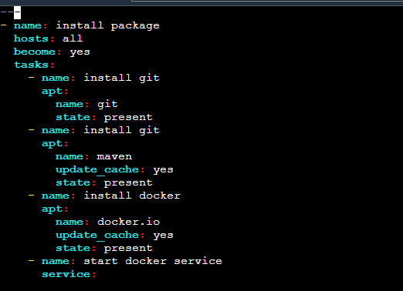

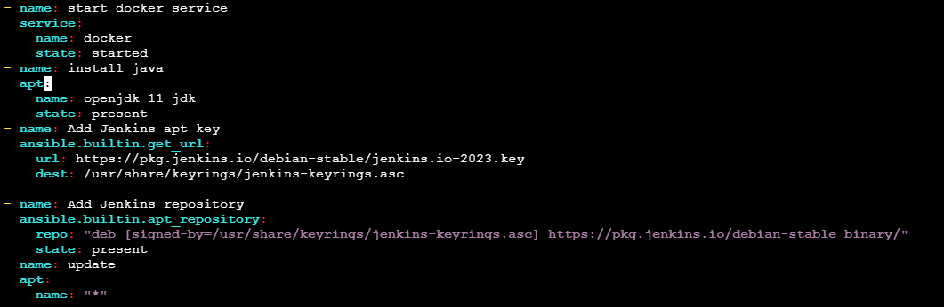

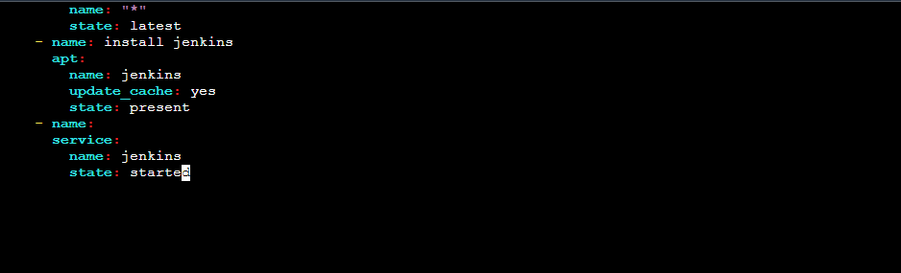

**Run the all command successfully.**

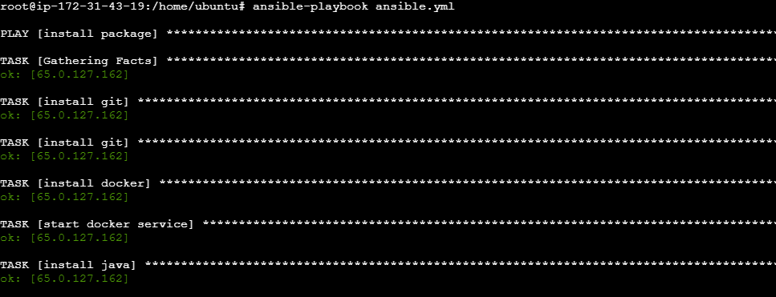

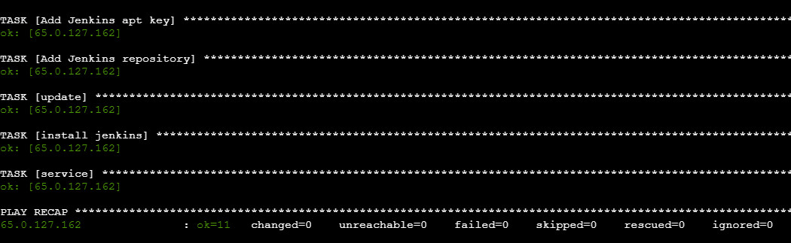

**After run go to the target host and check all package has been successfully installed or not**

**Command:- git –version (for check git package )**

**Command:- mvn –version ( for maven installation package)**

**Command:- docker –version (for docker installation package)**

**Command: jenkins –version (check jenkins –version)**

**Command: java –version (check java package)**

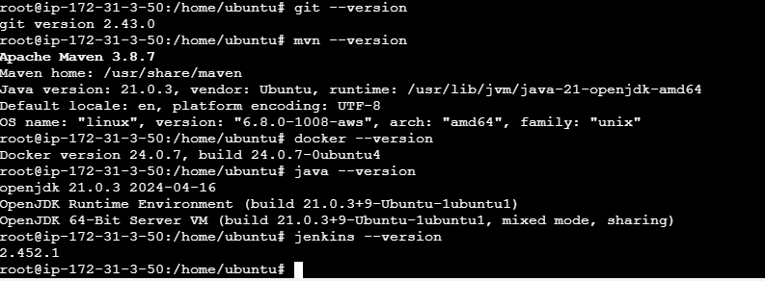

**So by checking version all package has been successfully installed on target host machine.**

**Now, open the jenkins:-**

**First go to the internet browser:-**

**Search public ip of target machine:8080 (8080 default port of jenkins)**

**65.0.127.162:8080**

**After open the below page will open**

**So, now need to login with Administrator password.**

**So go to the mention path and copy and paste with vi editor on target host where jenkins install.**

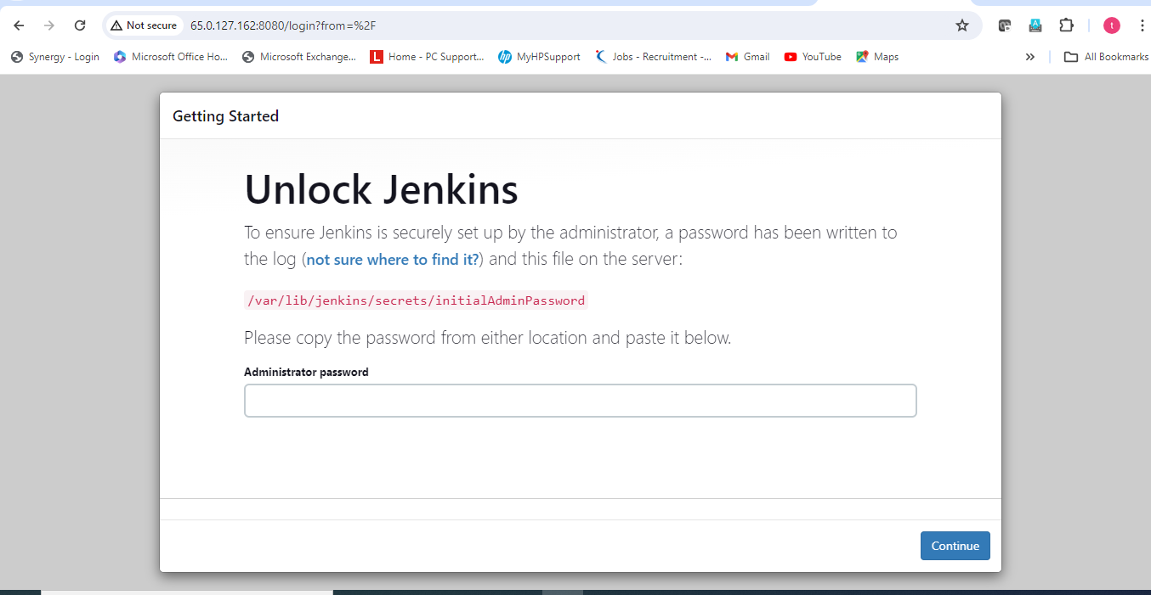

**Path:- vi** /var/lib/jenkins/secrets/initialAdminPassword



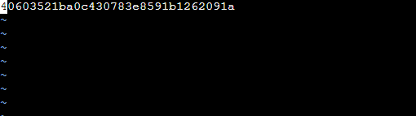

**Copy the above code and paste on jenkins administrator password.**

**After paste the password click on continoue on the bottom right side.**

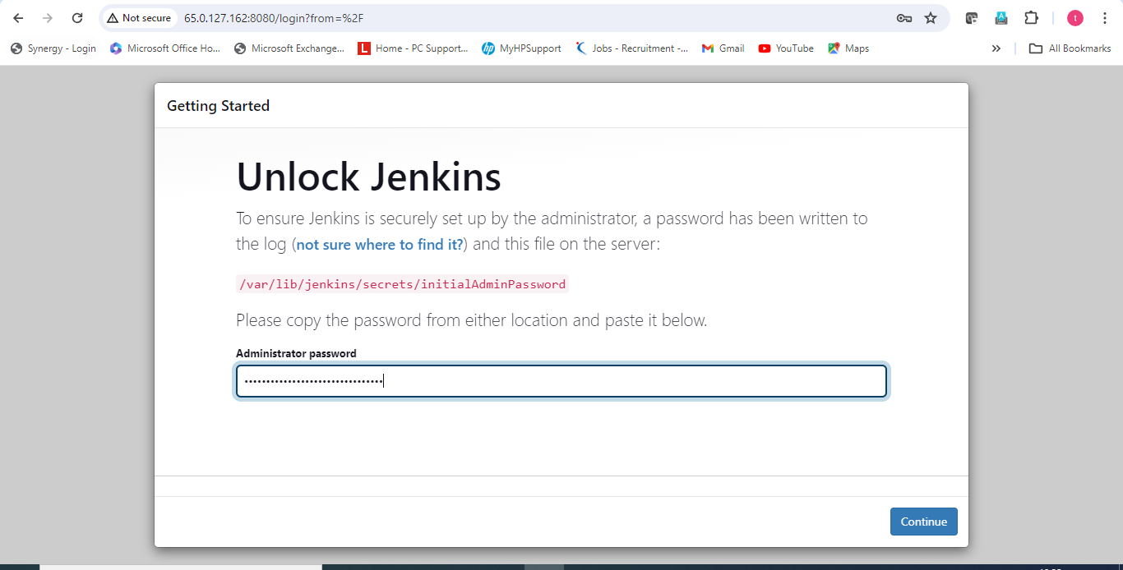

**Click on suggested plugin install**

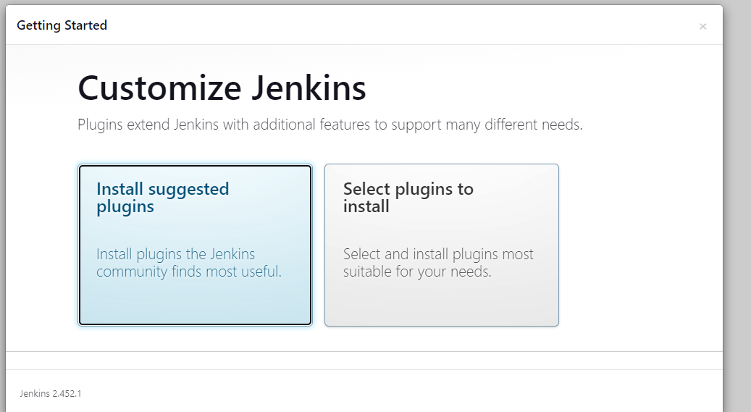

**All the suggested plugin is installing one by one.**

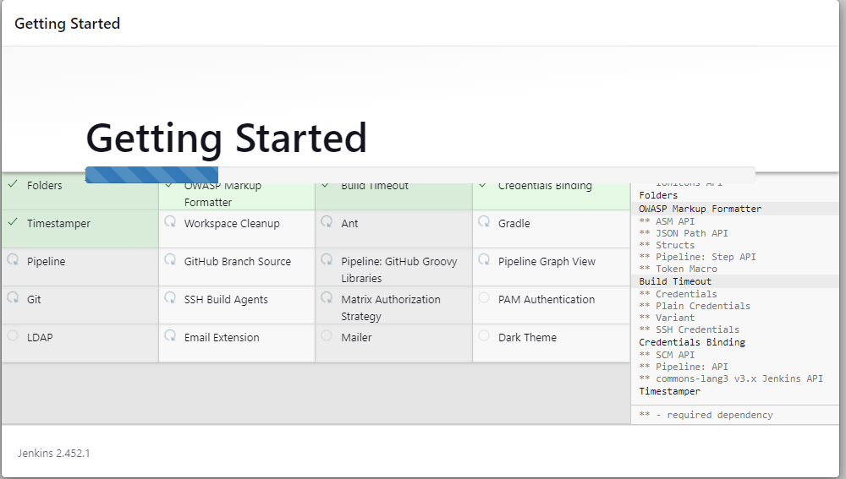

**After install all suggested plugin set the credentials of jenkins. And click on save and continou.**

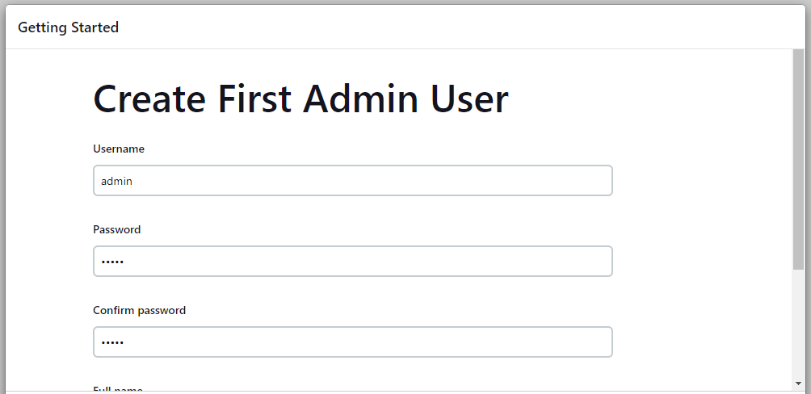

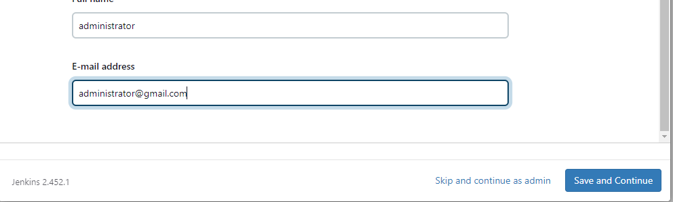

**After save and contionue click on save and finish.**

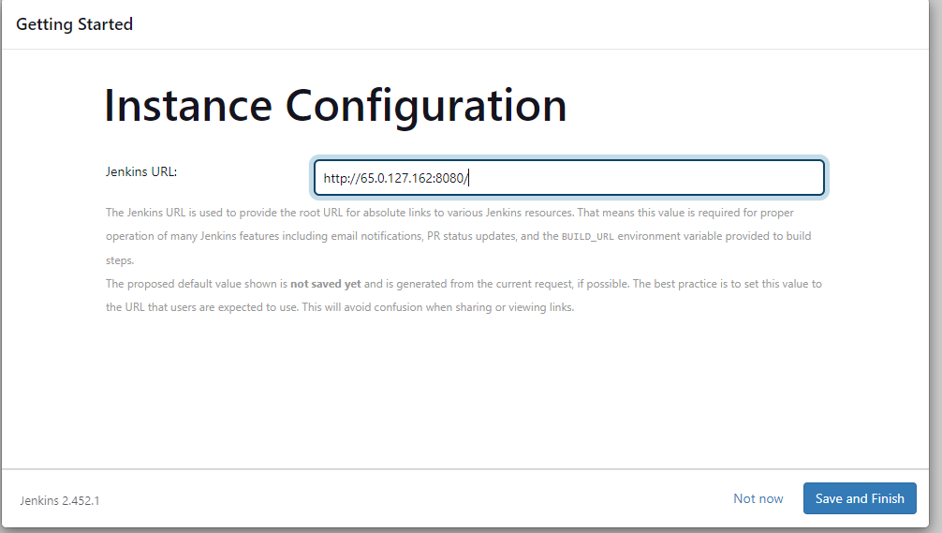

**And then click on start using jenkins**

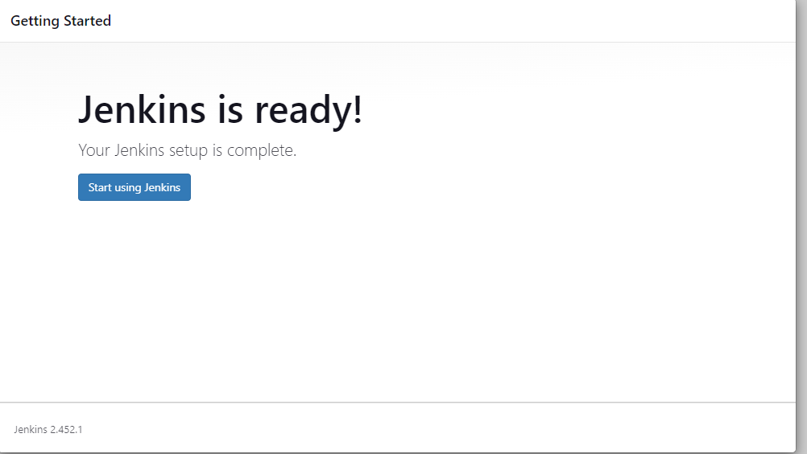

**After click on start using jenkins, jenkin dashboard will open.**

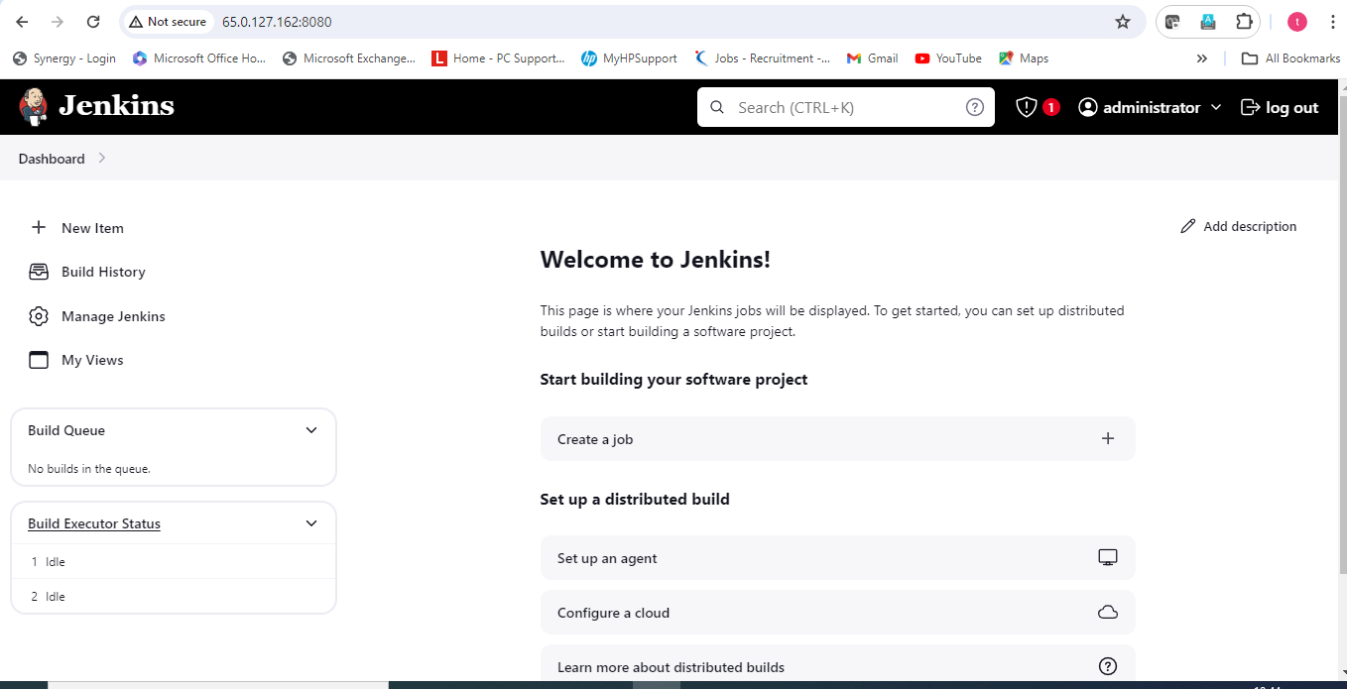

**The all requrired package has been successfully installed by ansible playbook.**

**So, now I am starting the project from git.**

**Assuming, I am developer and commit all the code from own local machine star-agile-banking-finance folder and push the code on git-hub.**

**This below folder available on my local machine**



**Command:- git push –u origin master (push the commit on own github**

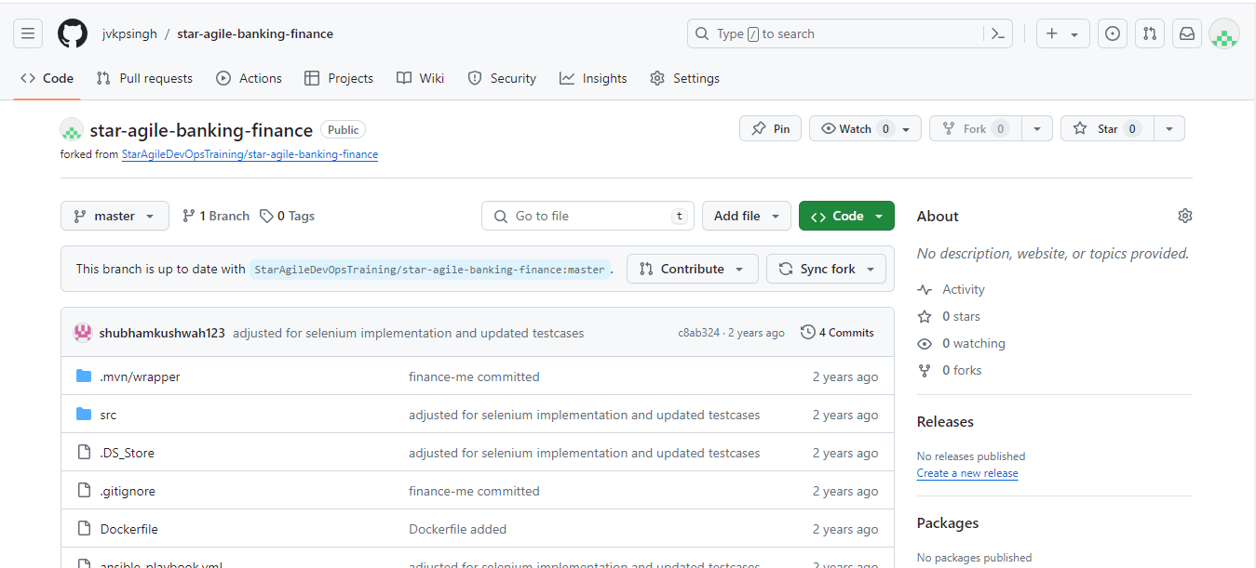

**After push the master on github build the code from maven by using jenkins and deploy the code on docker.**

**First go to the jenkins dashboard and click on new item.**

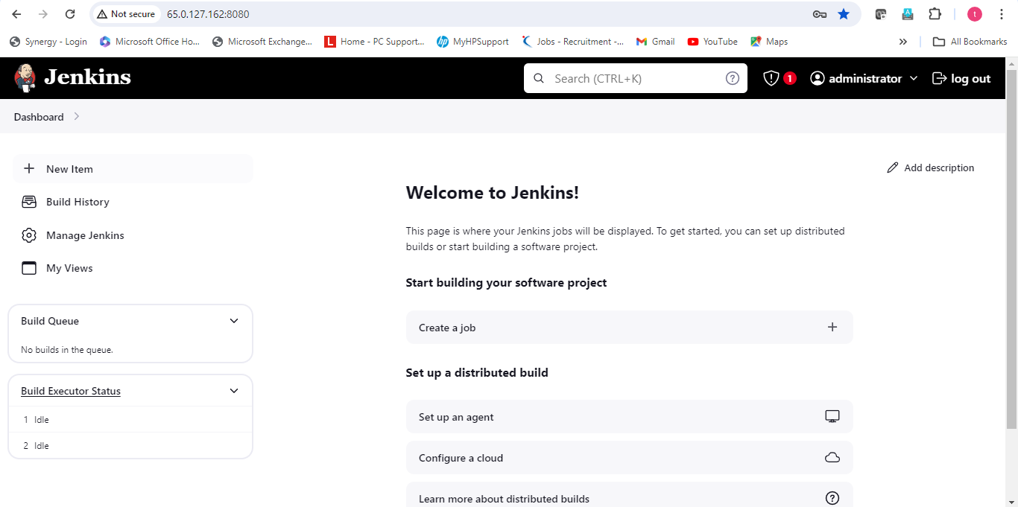

**After click on new items enter the item name and click on pipeline and then click on ok**

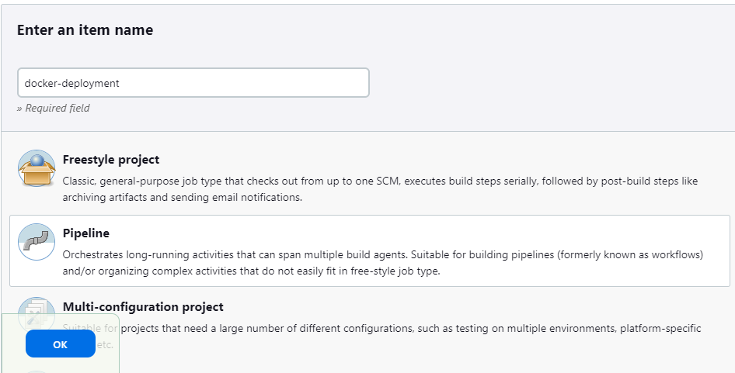

**Write the description.**

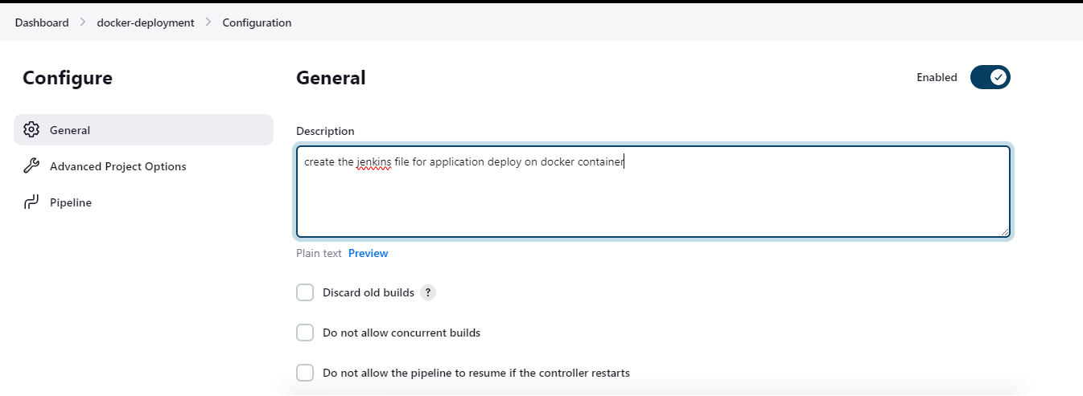

**After write description drop down and choose the Build Triggers.**

**Build Triggers:- poll scm (H/2 * * * *)—means if the any changes or commit on github build triggers and run the jenkins pipeline scripted code .**

**H/2 means:- every 2 minutes pol scm will go to the github and check if any code changes and commit the code by developer thet will pull and run the code whatever written in scripted pipeline.**

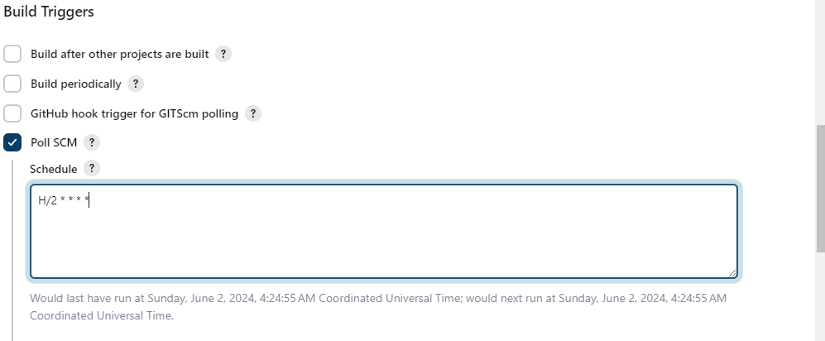

**After select build triggers drop down jenkins page and go inside pipeline and select pipeline script**

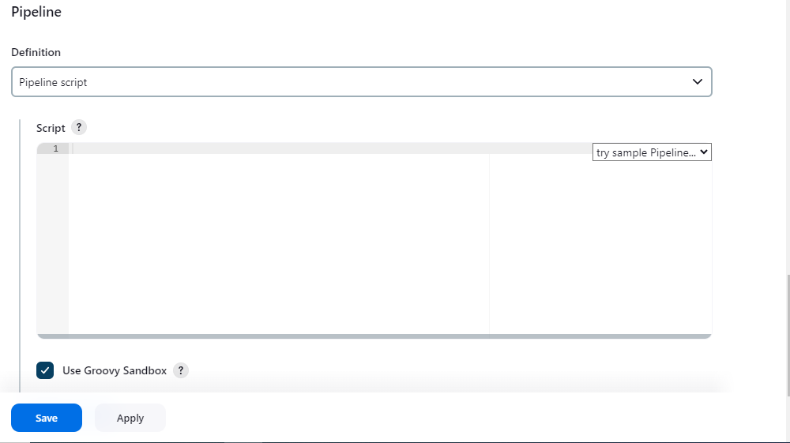

**Before write the Ci-Cd pipeline script make sure docker is available in jenkins group or not.**

**Command:- sudo usermod –aG docker jenkins (add the user in jenkins group)**



**After add docker in jenkins group. Will check that has been added or not**

**Command:- cat /etc/group**

**So bottom on the page docker has been successfully added in groups.**

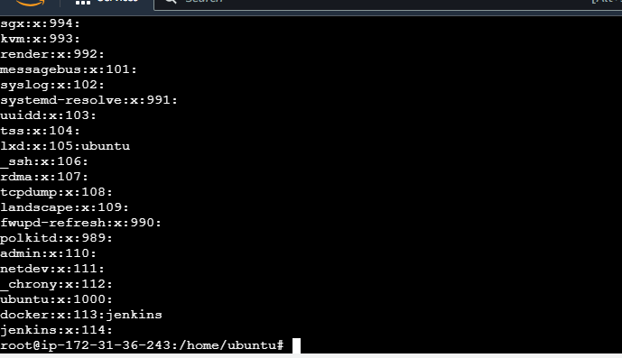

**After added docker in groups go inside jenkins pipeline script write th ci-cd code.**

**# I am writing the ci-cd script in declarative pipeline scripted.**

**pipeline { // this is the entry point of the declarative script**

**agent any // I am not declared the any agent node for run the ci-cd script its will get default agent master agent node.**

**Stages // start the stages from here**

**{**

**stage("checkout the code from git repositry") // write the stage inside stages for checkout the code from github**

**{**

**steps { // inside stage write the steps means what I will perform the action write inside steps**

**git url:** [**https://github.com/jvkpsingh/star-agile-banking-finance.git**](https://github.com/jvkpsingh/star-agile-banking-finance.git) **//url of the github from where checkout the code**

**}**

**} // close the stage and steps by braces**

**stage("clean the target directory") // write a more one stage for clean the target**

**{**

**steps {**

**sh "mvn clean"**

**}**

**}**

**stage("after clean validate the code") //after clean write the stage for validate the code**

**{**

**steps {**

**sh "mvn validate"**

**}**

**}**

**stage("after validate compile the code") //after validate create one more stage for compile the code and check syantax error.**

**{**

**steps {**

**sh "mvn compile"**

**}**

**}**

**stage("after compile test the code") //after compile test the code such as unit testing usercase testing etc.**

**{**

**steps {**

**sh "mvn test"**

**}**

**}**

**stage("after test package the code in jar") //after test build the code in jar format**

**{**

**steps {**

**sh "mvn package"**

**}**

**}**

**stage("after build completed build the image by docker") //after build code build the image by using docker.**

**{**

**steps {**

**script {**

**sh "docker build -t jvkpsingh/bankingproject:v1 ."**

**sh "docker images"**

**}**

**}**

**}**

**stage("after build image by docker push the image on dockerhub") //after build push the image on dockerhub**

**{**

**steps {**

**withCredentials([string(credentialsId: 'jvkpsingh', variable: 'dockervariable')]) {**

**sh "docker login -u jvkpsingh -p ${dockervariable}" //login the docker by username and variable password**

**sh "docker push jvkpsingh/bankingproject:v1" //after login push the image on the dockerhub**

**}**

**}**

**}**

**stage ("after push image on docker hub deploy the application on docker container")**

**{**

**steps{**

**sh "docker run -itd --name bankingcontainer -p 32768:8081 jvkpsingh/bankingproject:v1 "**

**sh "docker ps -a"**

**echo 'application has been successfully deploy'**

**}**

**}**

**}**

**}**

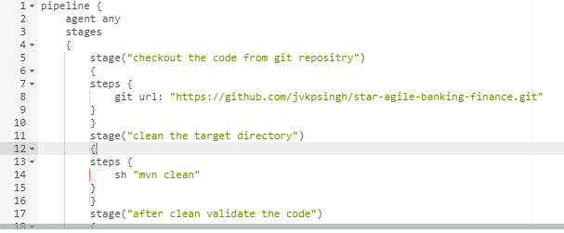

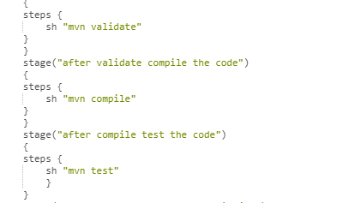

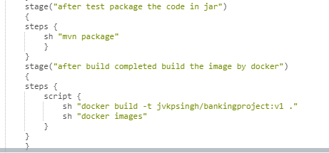

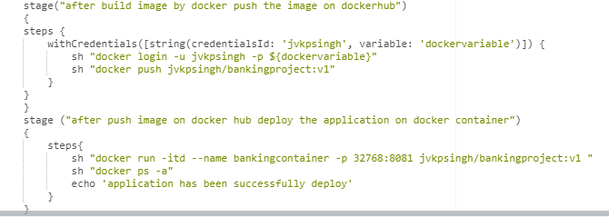



**After write the code click on apply and save .**

**So I am going to explain of the push stages on docker hub.**

**How to write the code for push image on docker hub by using jenkins.**

**First go to the scripted pipeline page. Where has been writen all script for jenkins ci-cd.**

**Click on pipeline syntax.**

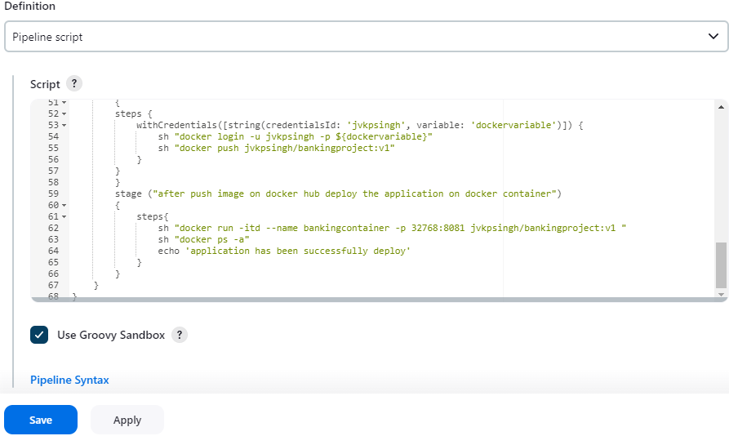

**After click will open new tab of pipeline syntax.**

**Click on sample steps and write withCredentials Bind Credentials to variable.**

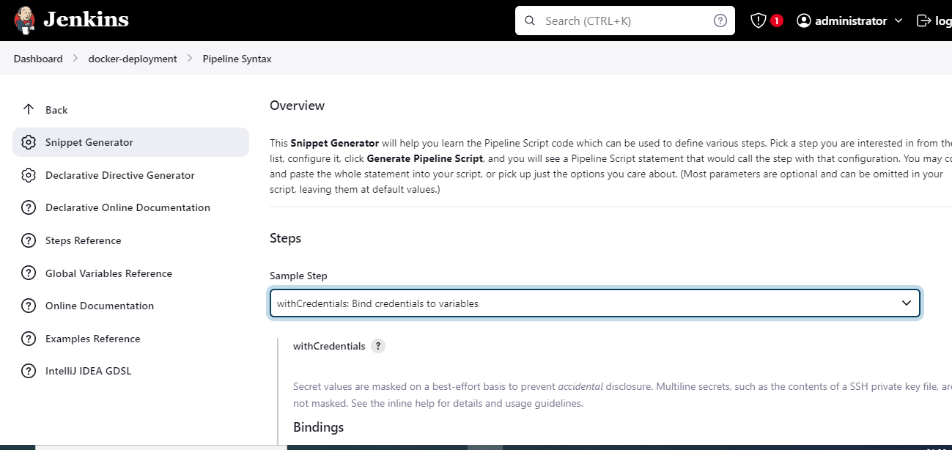

**After write sample steps, click on Add icon and then select secret text**

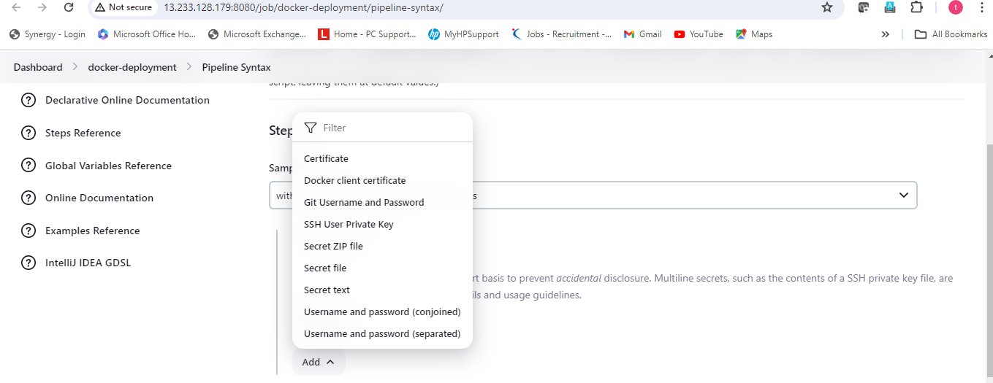

**After select secret text, write the variable (it name could be any custom name) and then click on ADD icon and then again on jenkins.**

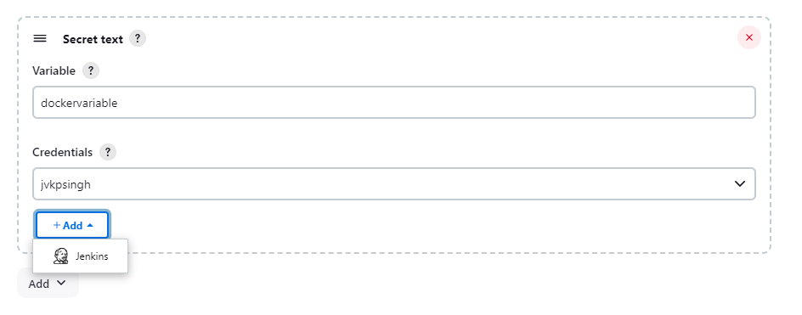

**After click on jenkins, open jenkins credentials provider.**

**Domain would be default-global credentials (no need to change)**

**Kind:- select secret text**

**Scope: would be default**

**Secret: github password**

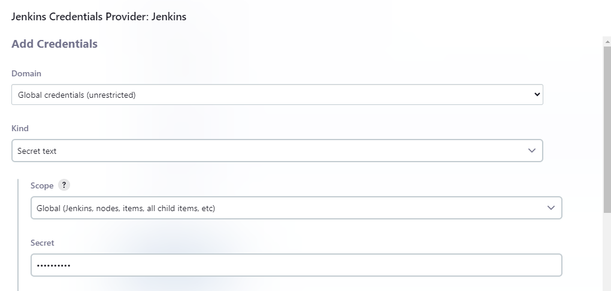

**Id:- github username**

**Description:- optional and then click on Add icon.**

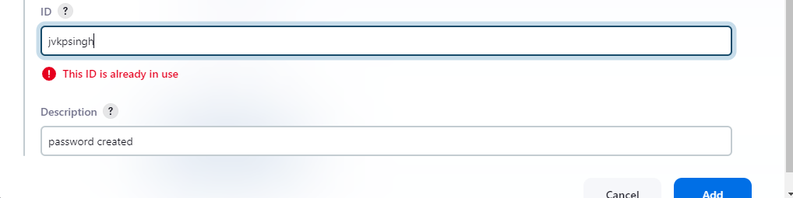

**After click on Add credentials will be addedd and click on generate pipeline script.**

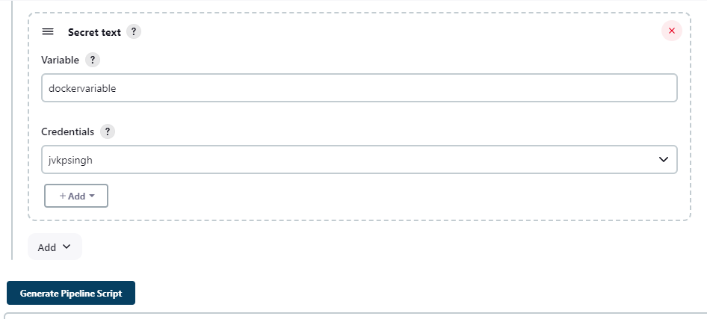

**After click on generate pipeline script.below script would be generated.**

**withCredentials([string(credentialsId: 'jvkpsingh', variable: 'dockervariable')]) {**

**so copy the code and then paste inside push stage.**

**stage("after build image by docker push the image on dockerhub") //after build push the image on dockerhub**

**{**

**steps {**

**withCredentials([string(credentialsId: 'jvkpsingh', variable: 'dockervariable')]) {**

**sh "docker login -u jvkpsingh -p ${dockervariable}"**

**sh "docker push jvkpsingh/bankingproject:v1"**

**}**

**}**

**}**

**After, write the script build the code .**

**So, I am using poll scm build triggers means, if the any changes or commit on source code on github so build will be triggers and run the scripted pipeline code.**

**Steps1:- I will go to the github and will change the code and commit the code after commit build will be trigger by poll scm and scripted pipeline run.**

**So now I am in github and change the accountservice.java code**

**So, I wiill remove the braces and then add.**

**So firstlt click on edit icon and remove braces and then add.**

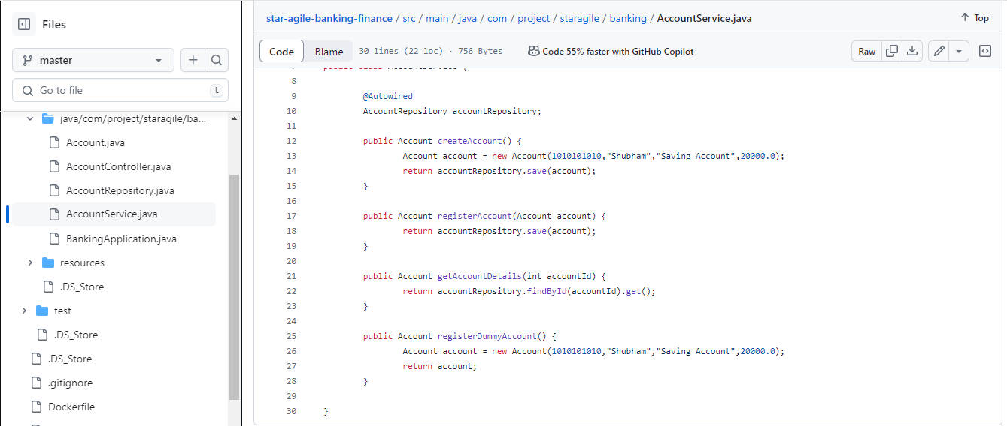

**After remove braces and add click on commit changes icon on the right top.**

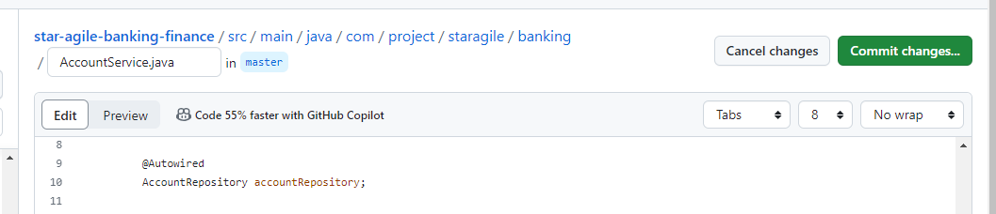

**After click on commit changes. Write the commit message and then click on commit changes.**

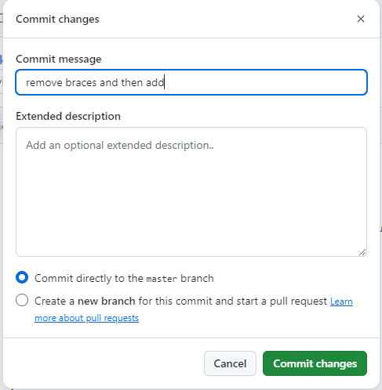

**When click on commit changes, after 2 min build will be triggers by poll scm because I have set the build triggers time 2 min and checkout the github and then run scripted pipeline.**

**Poll scm :- H/2 * * * \***

**Now go to the jenkins and then click on the docker-deployment item.**

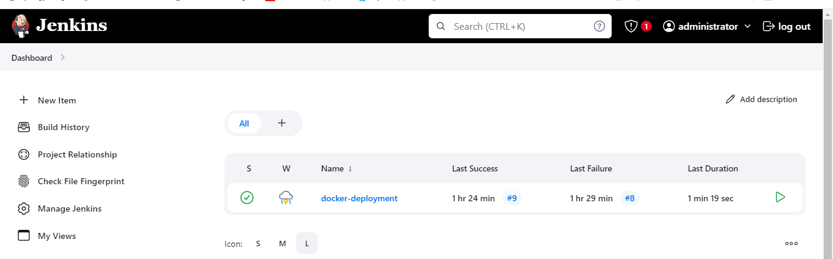

**After 2 min all stages has been successful run on below screenshot image.**

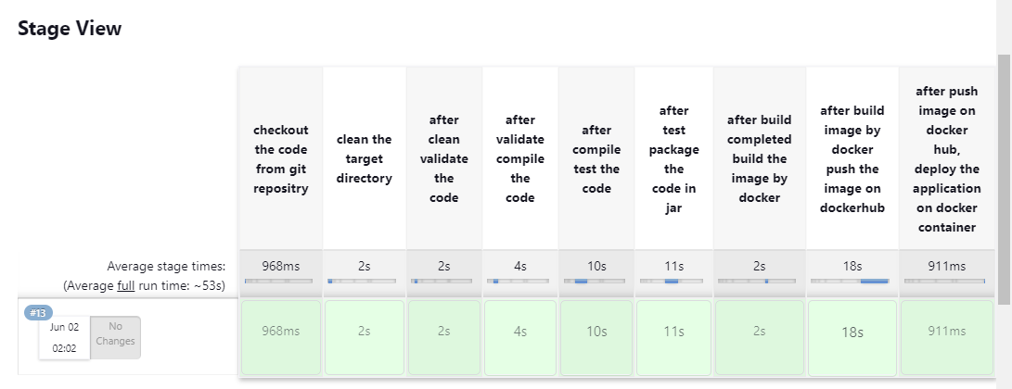

**After successfully run stages go to the dockerhub and then check images has been push or not.**

**Image name:- jvkpsingh/bankingproject:v1 ( so finally my docker image has been successfully push on the dockerhub and version is v1.**

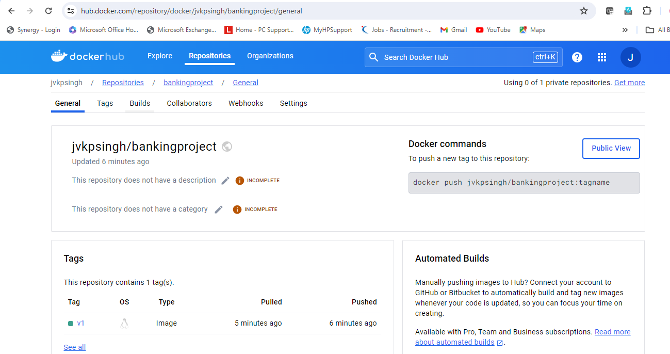

**After push will check, check my image has been available or not on local machine.**

**Command:- docker images**



**Now check my container has been running or not.**

**Command:- docker ps –a**



**So, my container has been running successfully.**

**So now go to the internet browser and then check my application has been deploy successfully or not and access with internet or not.**

**Command:- public ip terraform instance: 32768 ( I have enable 32768 port)**

**Command: 13.233.128.179:32768**

**So finally, my banking finanace project has been successfully deploy.**



**After deploy according to project I will use automatic monitoring tool by using prometheous and grafana.**

**Prometheus and Grafana – For Automated Monitoring and Report Visualization**

1. **So, first, go to the ansible server and then write the playbook for install Prometheus and grafana.**
2. **So, I will install Prometheus by playbook on target server where docker server,git,Jenkins.maven has been available and where container is running.**

**Because, Prometheus will collect the data from docker that how many container running, stop cpu utilization memory storage etc.**

1. **after Prometheus, install grafana by ansible playbook on ansible ec2 instance( means in which ec2 instance ansible server is running)**
2. **when Prometheus and grafana will install so Prometheus will collect the data from target machine and send on grafana for visualize the data in graph, pie chart form etc.**

**so, lets start, I am going to ansible server ec2 instance and then add the public ip of the target machine (where install Prometheus and ansible machine where install grafana)**

**so, I will create the two groups inside hosts file**

**1st group:- demo**

**2nd group:- grafana**

**command:- vi /etc/ansible.hosts**



**Add the two group demo and grafana with ec2 instance public ip.**

**By demo group will install prometheous and by grafana group by install grafana.**

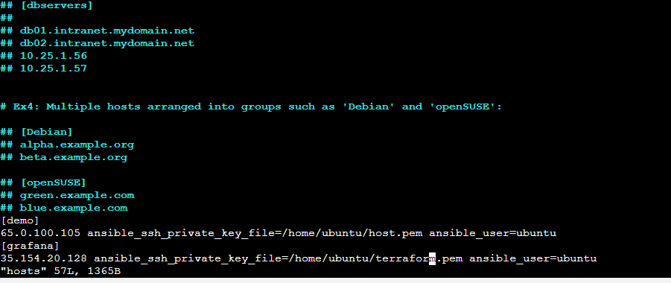

**Press ESC (exit from file)**

**Shift+:**

**Wq (change and save)**

**Enter**

**After add group and ip inside hosts file now will create ansible playbook for install Prometheus and grafana.**

**Command:- vi package.yml (create playbook)**

**---**

**- name: install package**

**hosts: demo**

**become: yes**

**tasks:**

**- name: install prometheus**

**apt:**

**name: prometheus**

**update_cache: yes**

**state: present**

**- name: install grafana package**

**hosts: grafana**

**become: yes**

**tasks:**

**- name: install transport https**

**apt:**

**name: apt-transport-https**

**state: present**

**- name: Add grafan apt key**

**ansible.builtin.get_url:**

**url: https://apt.grafana.com/gpg.key**

**dest: /etc/apt/keyrings/grafana.gpg**

**- name: Add grafana repository**

**ansible.builtin.apt_repository:**

**repo: "deb [signed-by=/etc/apt/keyrings/grafana.gpg] https://apt.grafana.com stable main"**

**state: present**

**- name: update**

**apt:**

**name: "*"**

**state: latest**

**- name: install grafana**

**apt:**

**name: grafana**

**state: present**

**- name: start service**

**service:**

**name: grafana-server**

**state: started**

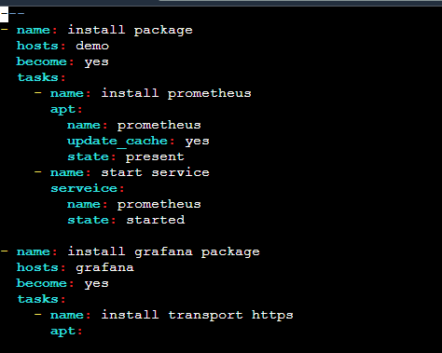

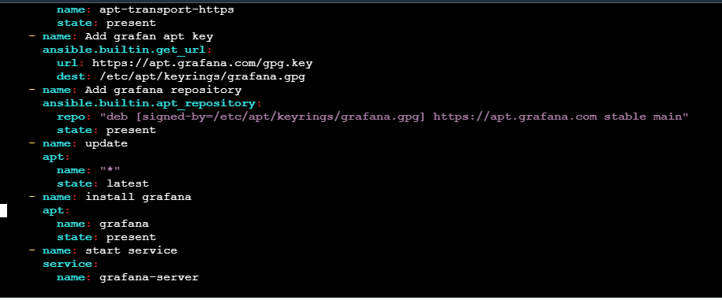

**Run the package.yml playbook**

**Command:- ansible-playbook package.yml**

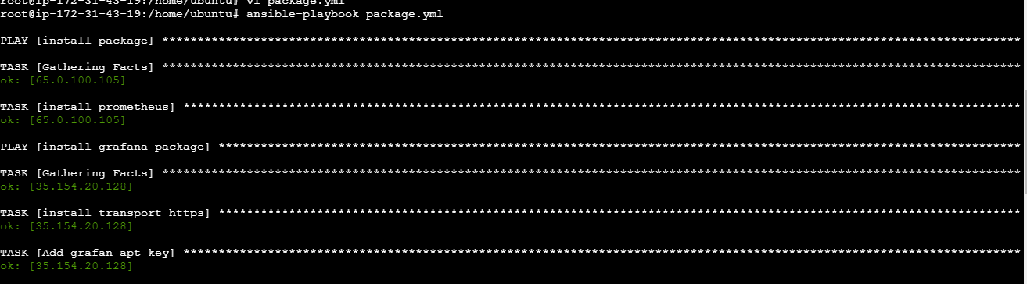

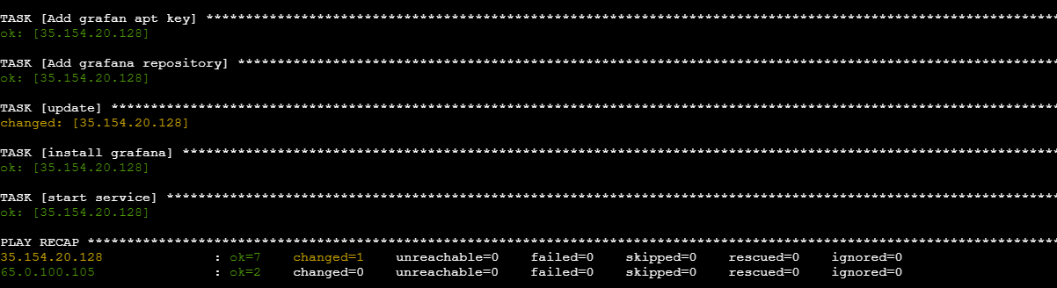

**So, above screenshot playbook has been successfully run.**

**Now got to the target host and then check that Prometheus has been installed or not.**

**Command:- Prometheus –version**

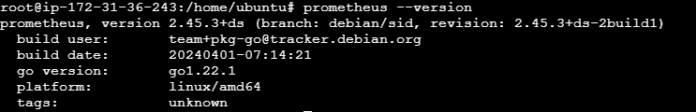

**So Prometheus server has been successful installed.**

**No go to the internet browser and the try to access.**

**Public ip of target machine:9090 (9090-default port of Prometheus)**

[**url:-**](url:-)[**https://65.0.100.105:9090**](https://65.0.100.105:9090)

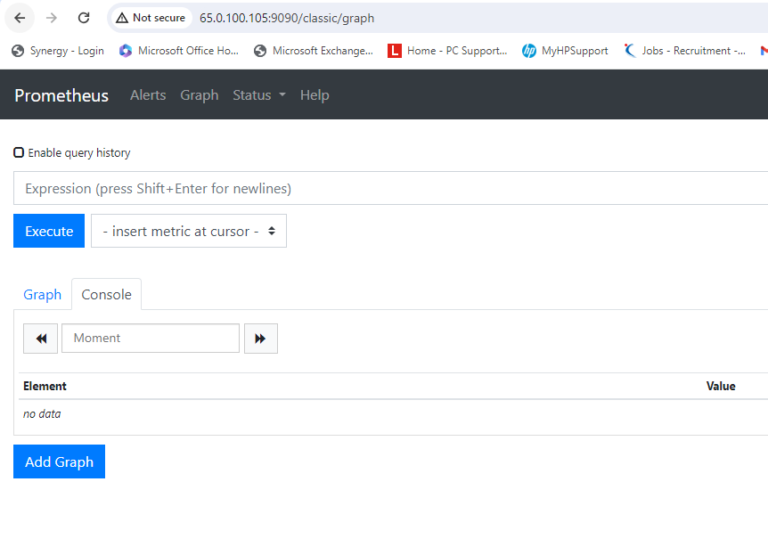

**So, prometheus has been successfully access on the internet.**

**Now, check grafana has been installed or not on my grafana machine.**



**It has been successfully installed.**

**So now I try to grafana server on the internet.**

[**url:-**](url:-) **public ip of grafana machine:3000 (3000 is the default port of the grafana machine)**

[**http://35.154.20.128:3000/**](http://35.154.20.128:3000/)

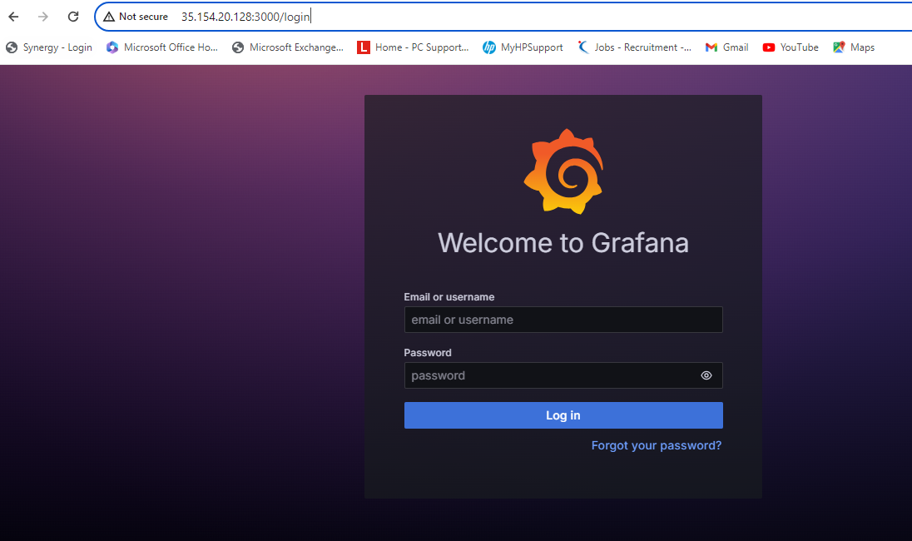

**So, grafana server has been successfully installed and access on the internet.**

**Note:- 3000 port must be enable on grafana ec2 instances**

**9090 port must be enable on prometheus ec2 instances.**

**Now, I will collect the docker container data( status, cpu utilization, running status, storage etc) via a prometheus. Means I will add the docker in prometheus target.**

**So first, go to the docker deamon for add the any port which port will also add in prometheus configuration file.**

**This port make the connection bw docker deamon and prometheus for data transferred to prometheus.**

**So, first write the command,**

**vi /etc/docker/daemon.json**

**press I (for insert) and then paste the below command:-**

**{**

**"metrics-addr" : "0.0.0.0:9323",**

**"experimental" : true**

**//9323 is not fixed we can give any port number accordingly.**

**After paste under docker daemon**

**Press esc (out from terminal)**

**Shift+:**

**Wq (changes will save)**

**Enter (hit)**



**After add metrics-addr in docker daemon and then restart the docker**

**Command:- service docker restart**

**After restart go to the internet bvrowser and then search**

**Prometheus server instance public ip:9323/metrics**

[**http://65.0.100.105:9323/metrics**](http://65.0.100.105:9323/metrics)

**So in this page I will go to the container line and then check my any docker container is running or not.**

**So see here paused container:- 0**

**Running container:- 0**

**Stop container:- 1**

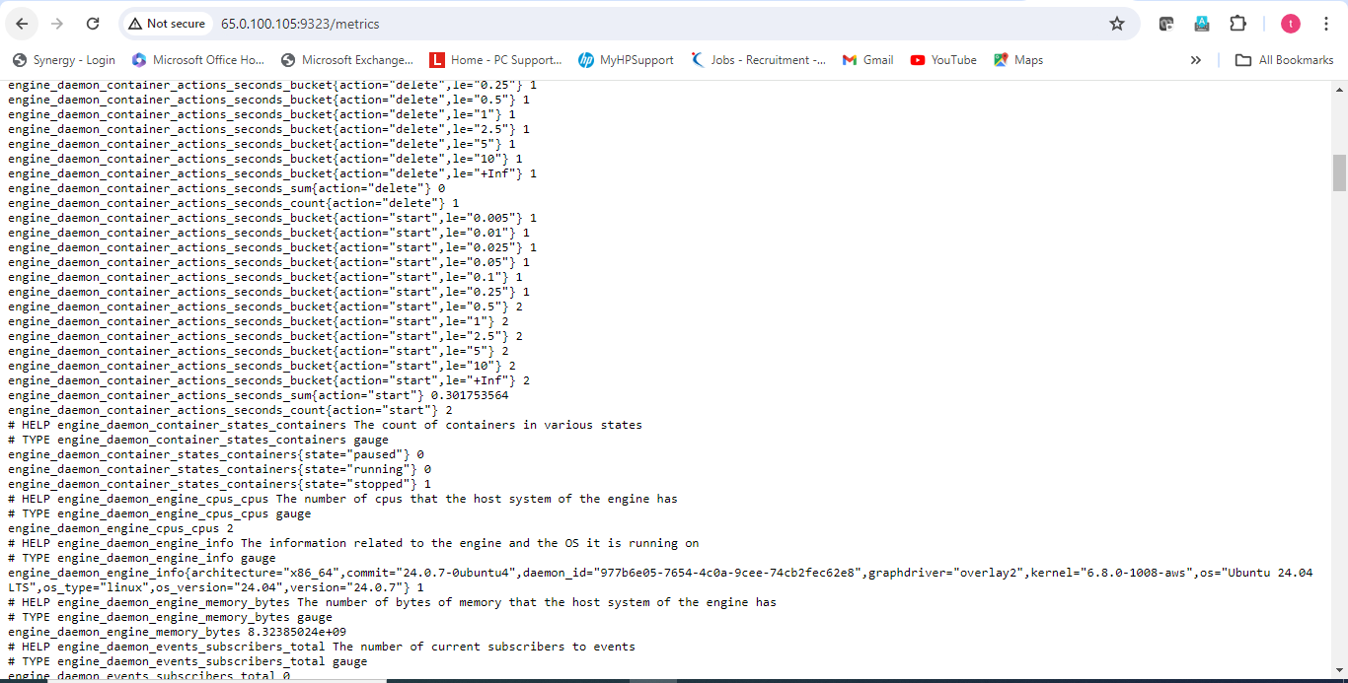

**So I will go to the Prometheus ec2 instance terminal and then check my container is stop or not as a data.**

**If stop so, I will start and then check that here my running container is showing or not.**

**Command:- docker ps (show running container)**

**Command:- docker start containerid (start the container)**

**After start refrwesh the above page and then check running container is showing or not .**

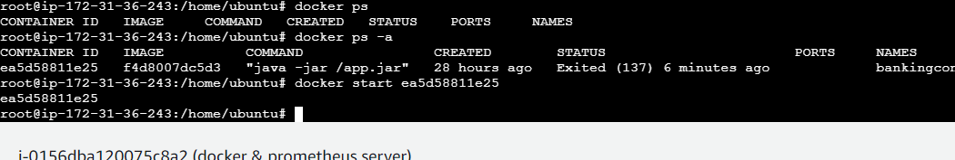

**So my one docker is stoped so, I have start the docker now I check on the**

[**http://65.0.100.105:9323/metrics**](http://65.0.100.105:9323/metrics)

**after refresh that running container is showing or not.**

**Paused container:- 0**

**Running container:- 1**

**Stopped container:- 0**

**So my previos screenshot my running container is 0 and stop container is 1 but when I have started the container so data will reflect here stop container is showing 0 and start container or running container is showing 1**

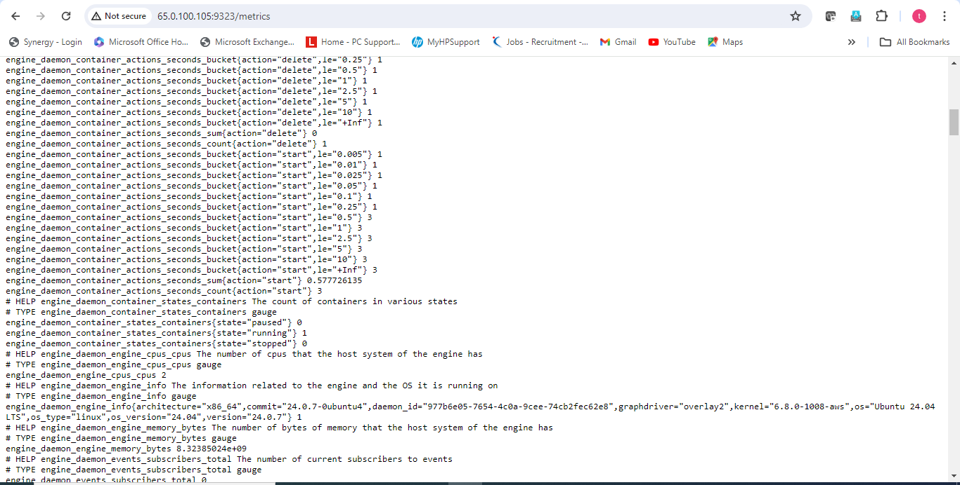

**So, now will add 9323 port inside Prometheus.yml file because Prometheus will collect the data from 9323 port and 9323 port has been docker daemon.**

**So, Prometheus will collect the data from docker, whatever happen.**

**So, first add the 9323 port inside Prometheus.yml.**

**- job_name: "docker"**

**# metrics_path defaults to '/metrics'**

**# scheme defaults to 'http'.**

**static_configs:**

**- targets: ["localhost:9323"]**

**(just take care of one thing that – job_name should be exactly the job_name of the Prometheus)**

**So, above command copy and paste inside Prometheus.yml**

**Command:- vi /etc/Prometheus/Prometheus.yml**

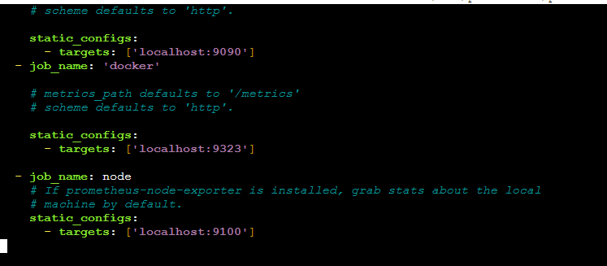

**Press Esc**

**Shift+:**

**Wq (change and save)**

**enter**

**after add port 9323 inside Prometheus start the Prometheus.**

**Command:- systemctl start Prometheus.**

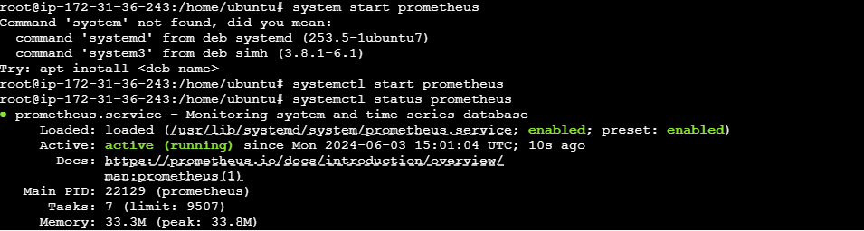

**After start refresh the Prometheus url on the internet.**

**url:-** [**http://65.0.100.105:9090/**](http://65.0.100.105:9090/)

**and click on status and then click on target icon.inside target docker has been added**

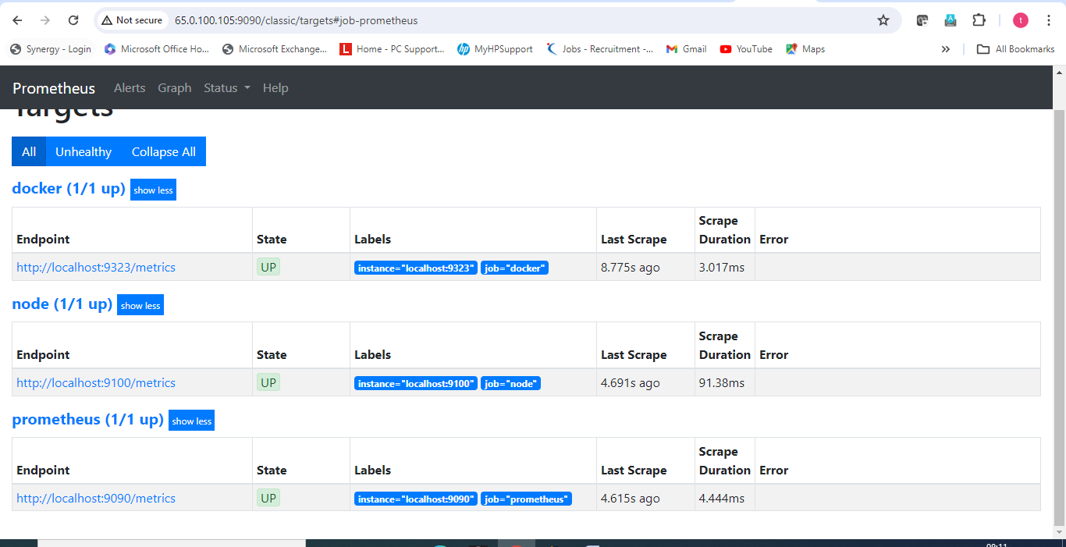

**So, I have added the docker port with Prometheus. So Prometheus will collect the data from docker and then shared with grafana for represent in graph form pie chart form etc.**

**So, now will go to the grafana dashboard:-**

**First will add data source Prometheus**

[**http://35.154.20.128:3000/login**](http://35.154.20.128:3000/login) **login with admin username and admin password.**

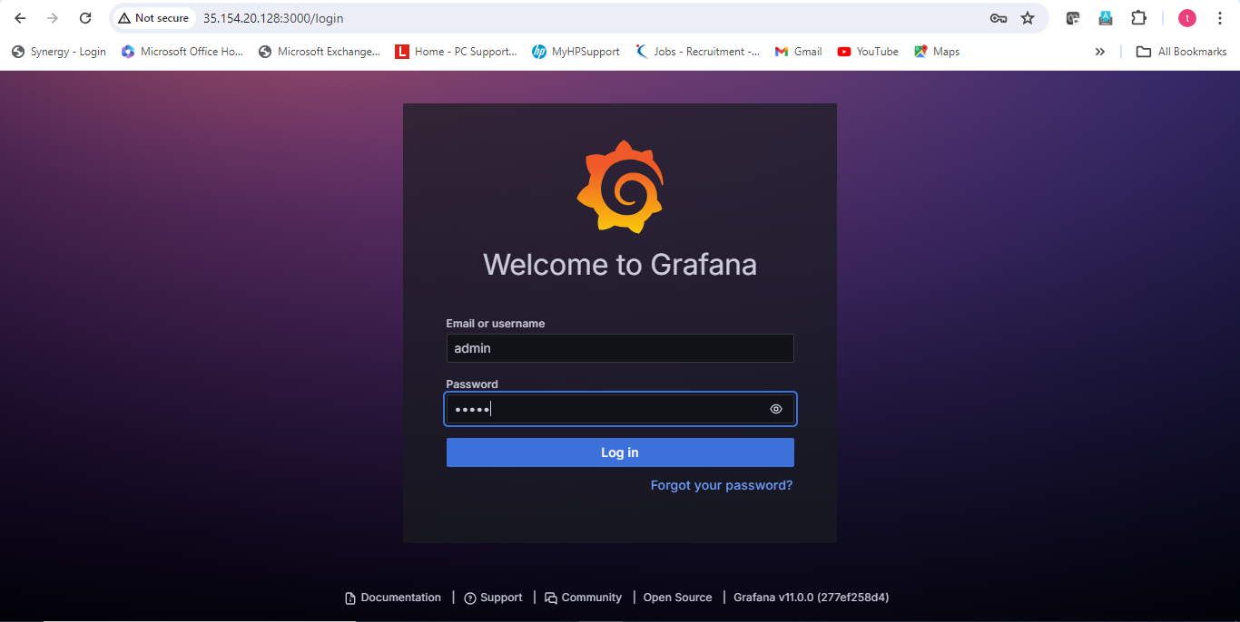

**After login add the data source. (so click on data sources icon)**

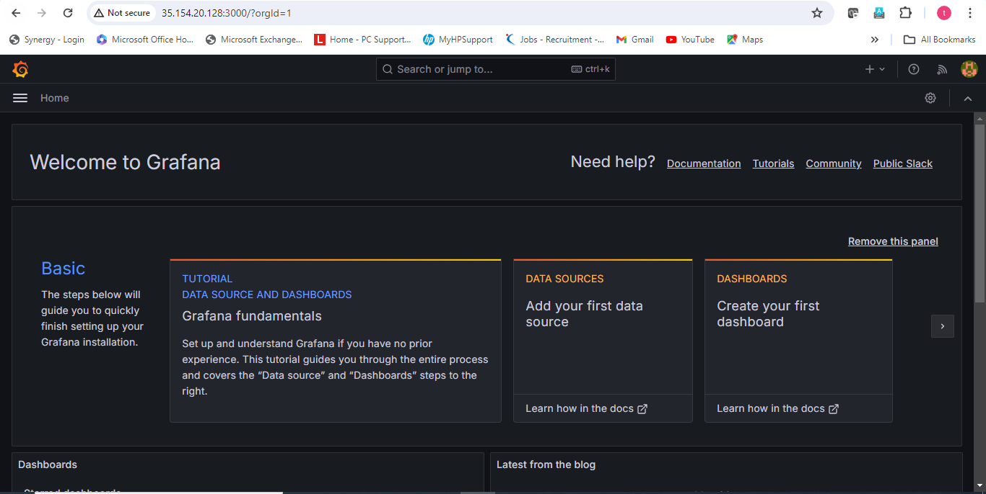

**And then click on Prometheus( because I want to retrieve the data from Prometheus)**

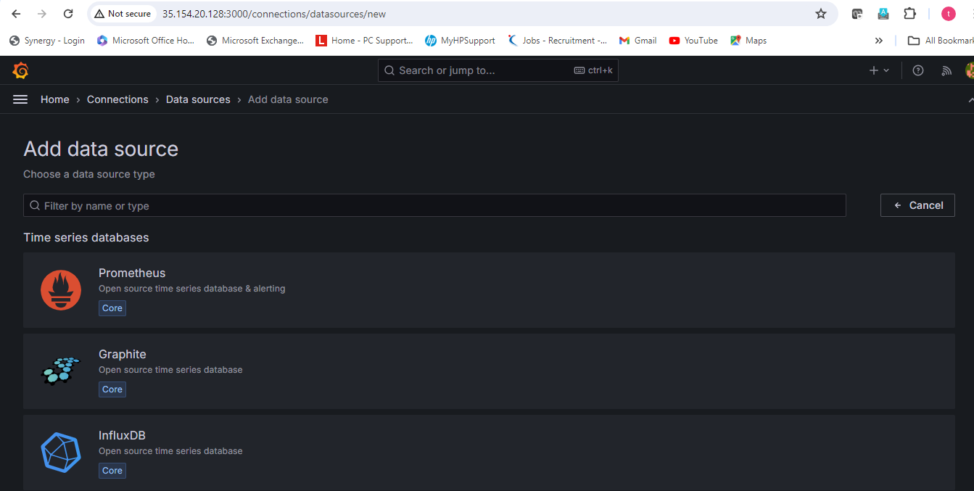

**Write the name of Prometheus and then url of Prometheus server(public ip of pometheus ec2 instance:9090/)**

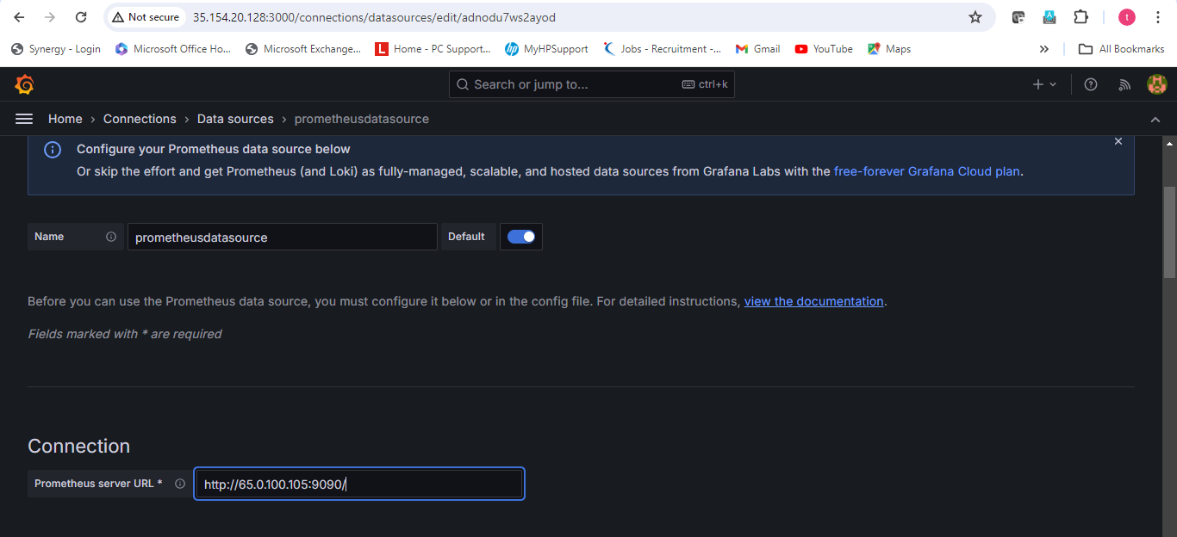

**Click on save and test**

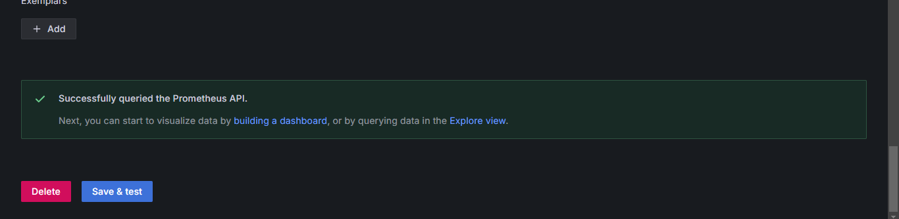

**Click on build a dashboard icon**

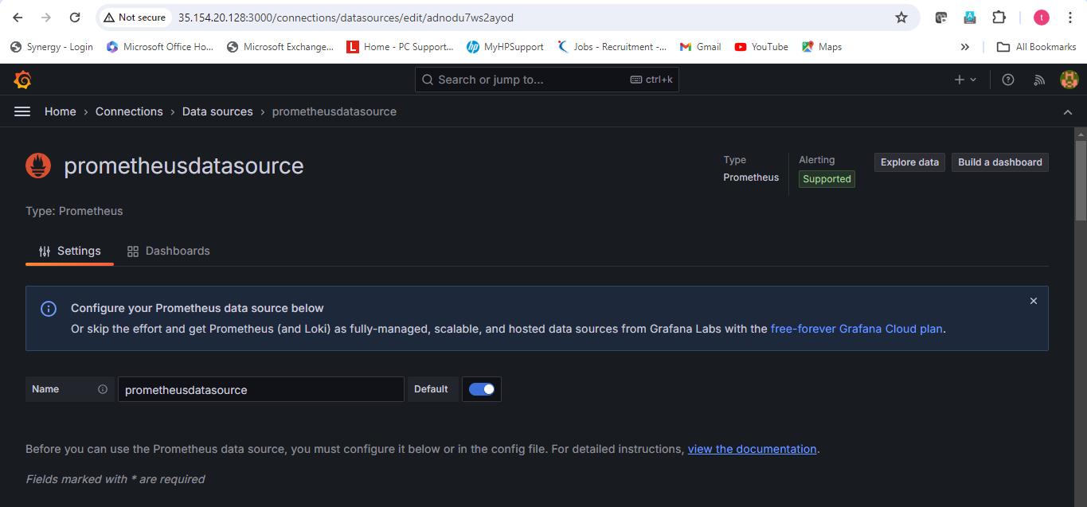

**And then click on Add visualization**

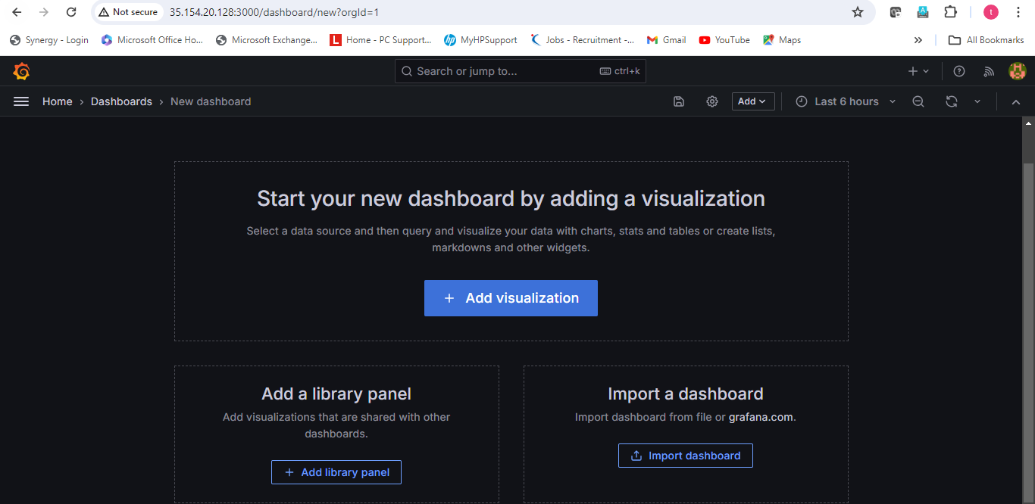

**Click on Prometheus data source**

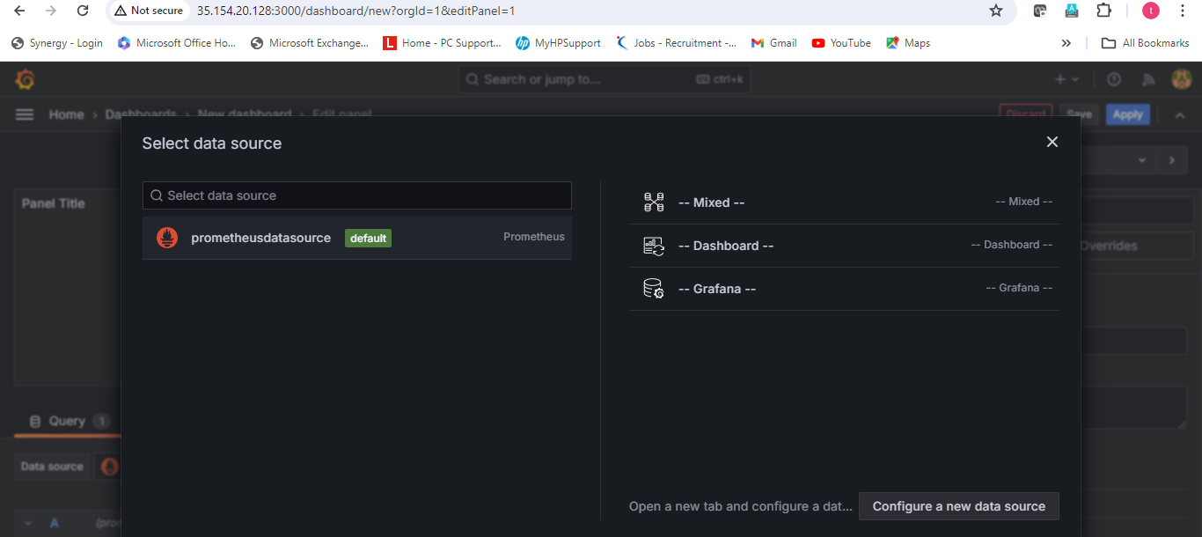

**After click this below dashboard has been open.**

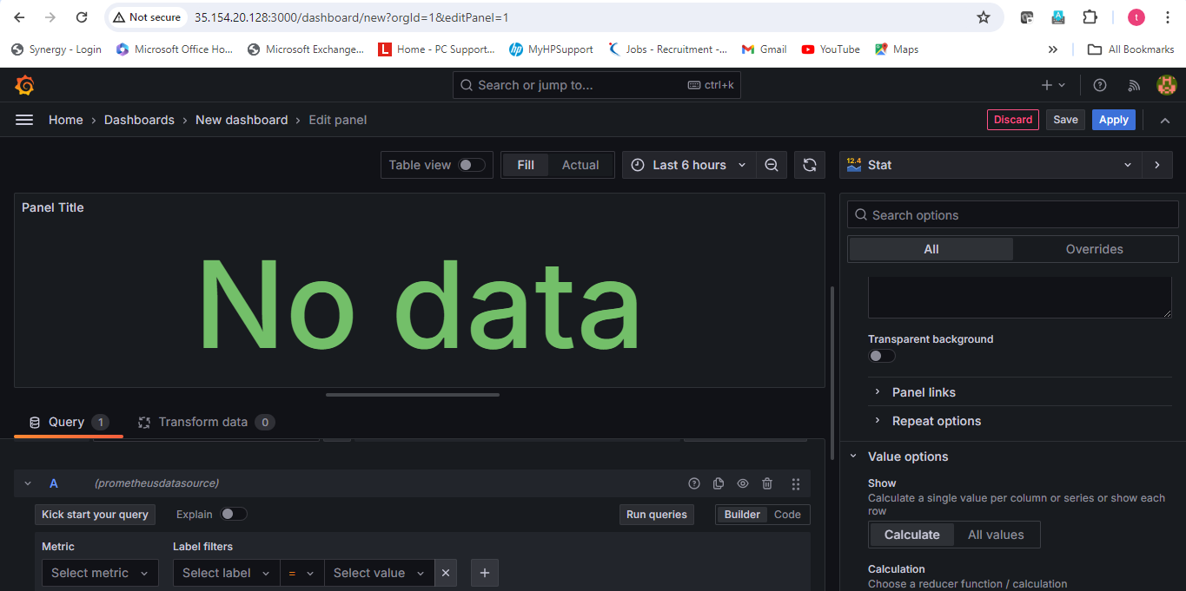

**Suppose I want to represent data that how many container is my stop.**

**Write this word under metric:-engine_daemon_container_states_containers{state="stopped"}**

**And then click run query.**

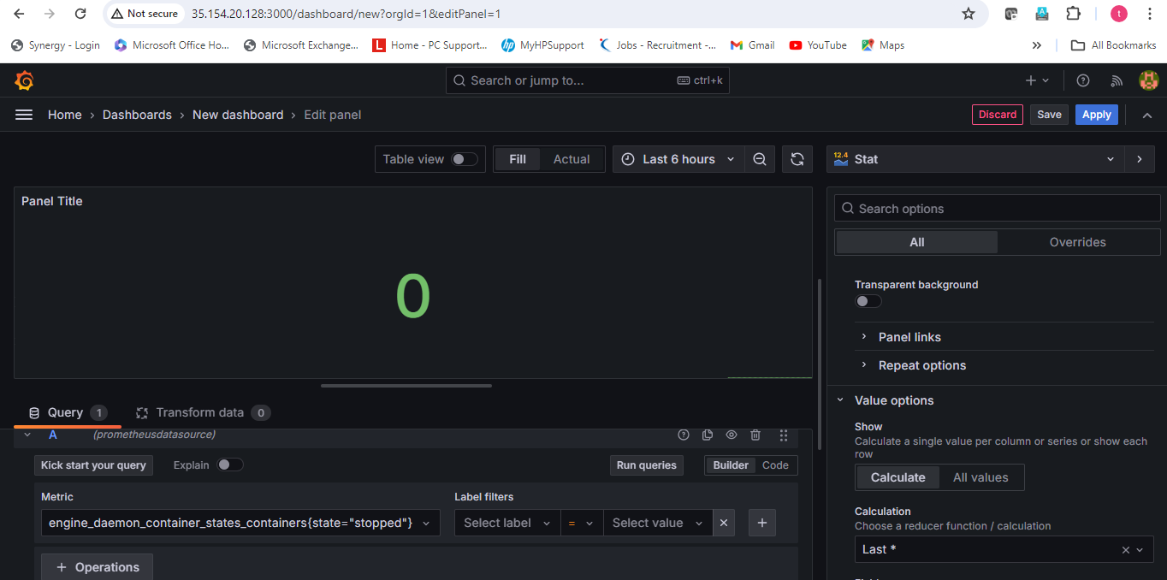

**After run query show there are nothing (zero container is stop)**

**If I want to check that how many container is my running:**

**Metrics:-- engine_daemon_container_states_containers{state="running"}**

**Click on run query**

**So that is showing there are one container is running.**

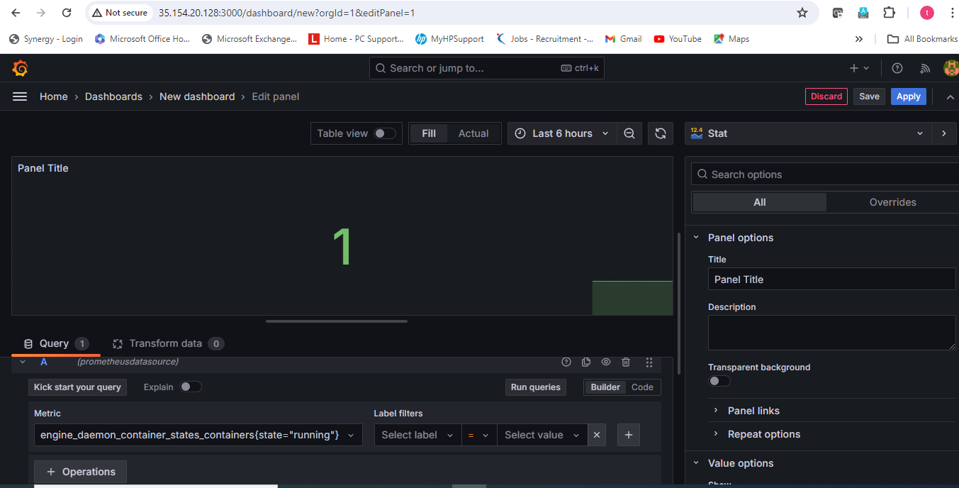

**Suppose I go to the prometheus ec2 instance and stop container and then check here what is out come.**

**Command:- docker stop containerid**

**So, you can look in screen shot my one container is running so, that’s proved whatever showing in grafana that there are one running container that is right.**

**So I have stop the running container and then check on grafana what shows.**

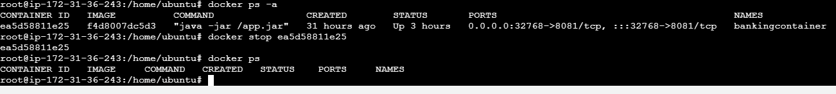

**So ,now will come on the grafana dashboard and then check .**

**First check running container because previously show 1 running container but now I have stop the container so, in grafana must be show 0 contrainer running and stop container 1.**

**Metrics:-- engine_daemon_container_states_containers{state="running"}**

**Click on Run Query.**

**So, showing running container is 0. Means that is showing exact right. Because I have stop the running container.**

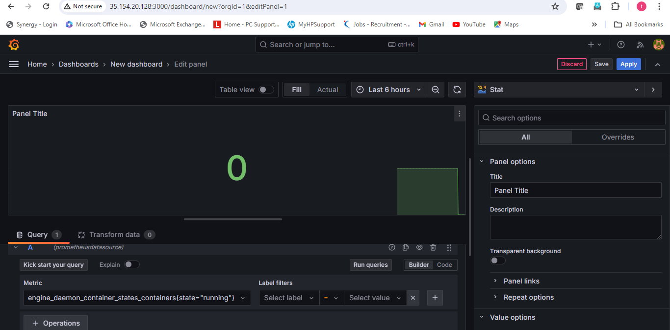

**So, I am checking how many container is stop. Because I have stop 1 running container so, stop container is 1. Because previously showing 0 stop container because 1 container is running but I have stop those container show must be show stop container 1 by grafana**

**Metrics:-** **engine_daemon_container_states_containers{state="stopped"}**

**Run query.**

**Stop container is 1.**

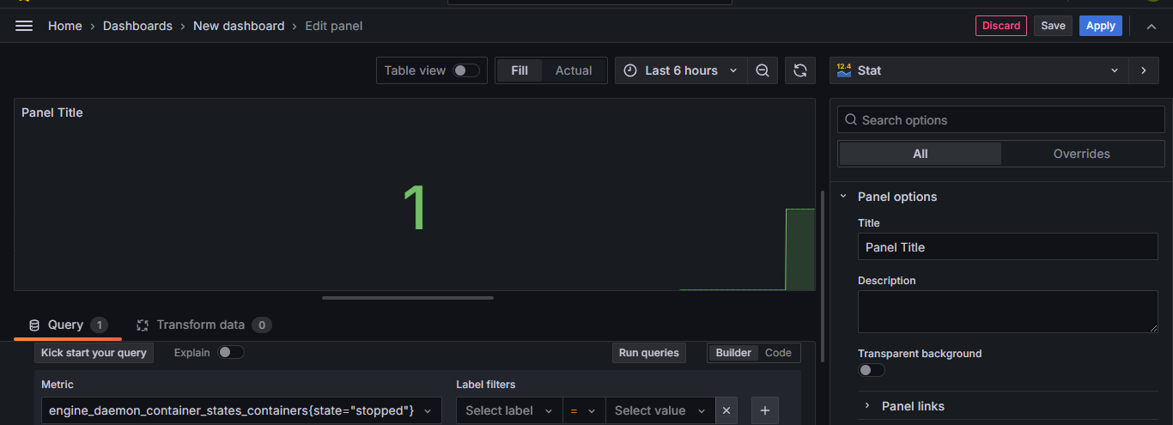

**If I want to check how many container is pause.**

**Metrics:- engine_daemon_container_states_containers{state="paused"}**

**Run query.**

**Paused container:- 0**

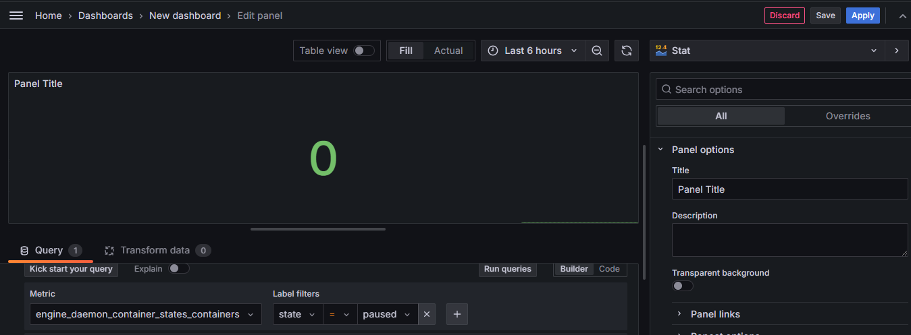

**So, I can visualize the data from grafana which will collect from Prometheus.**

**So, I can use different different category of metrics and then visualize the data.**

**I have also visualizing the data on below component.**

**1. CPU utilization**

**2. Disk Space Utilization**

**3. Total Available Memory**

**1. CPU utilization :-**

**select metric-node_cpu_guest_second_total**

**label filters- instance**

**select value:-** **localhost:9100**

**run query**

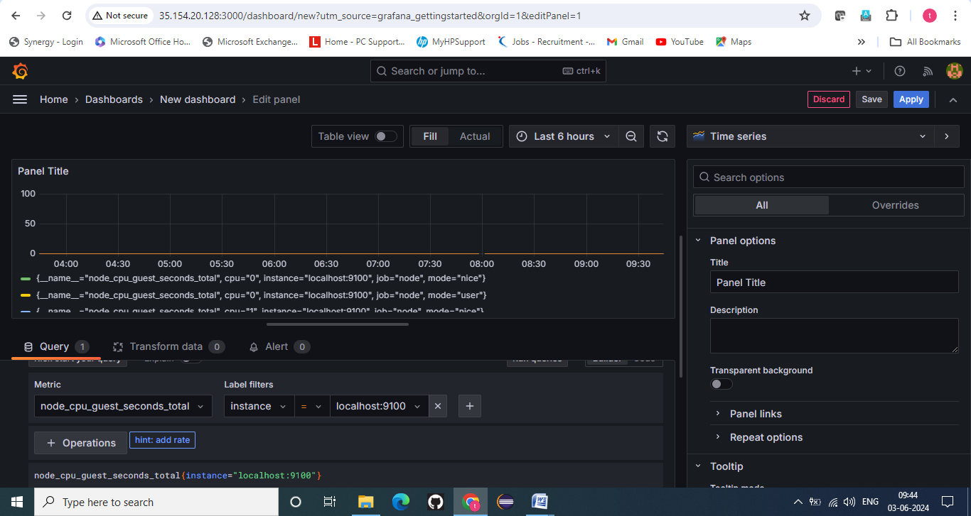

1. **Disk space utilization:-**

**select metric-node_disk_io_time_total**

**label filters- instance**

**select value:-** **localhost:9100**

**run query**

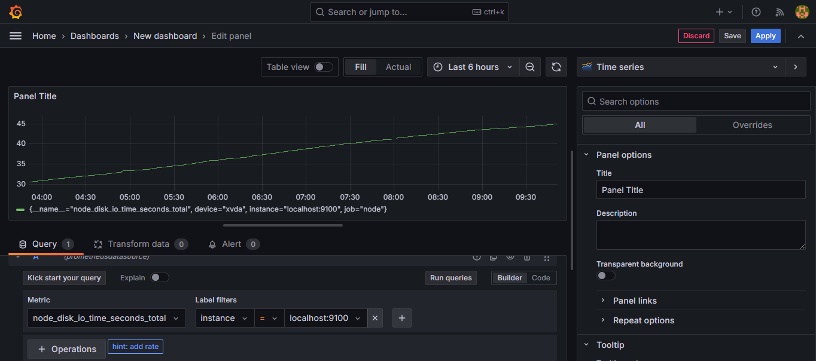

1. **Total available Memory:-**

**select metric-node_memory_memtotal_bytes**

**label filters- instance**

**select value:-** **localhost:9100**

**run query**

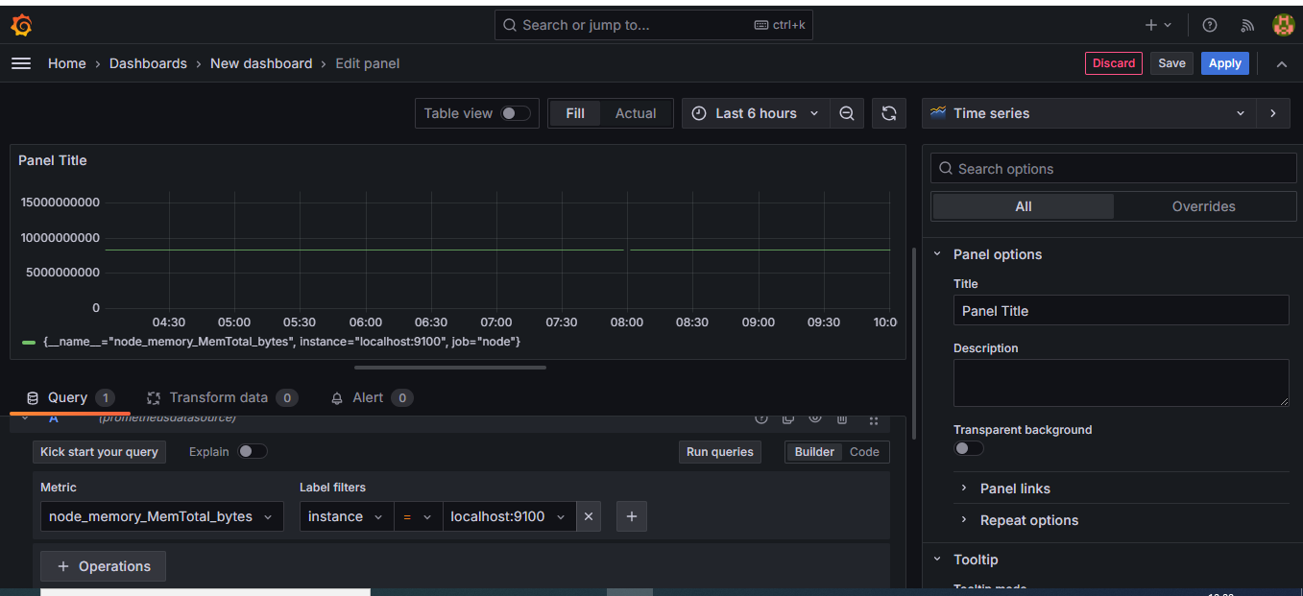

**So, finally project has been completed.**

**\*\*\*\*\*\*\*\*\*\*\*\*\*\*\*\*\*\*\*\*\*\*\*\*\*\*\*\*\*\*\*\*\*\*\*\*\*\*\*\*\*\*\*\*completed\*\*\*\*\*\*\*\*\*\*\*\*\*\*\*\*\*\*\*\*\*\*\*\*\*\*\*\*\*\*\*\*\*\*\*\*\*\*\*\*\*\*\*\*\*\*\*\*\*\*\*\*\*\*\***